

Sensitivity of the Advanced Virgo detector during O2 and O3 runs

D. Verkindt

VIR-1140A-21

https://tds.ego-gw.it/ql/?c=17389

28 October 2021

Change Record

Version | Date | Section Affected | Reason / Remarks
v1 | 25/10/2021 | All | First version

Table of Contents
1 Introduction 3
2 Sensitivity and BNS range for O2 3
3 Sensitivity and BNS range for O3 5
4 History of sensitivity 8
5 Bibliography 9

Introduction
This document present the sensitivity curves and BNS range that could be used as reference for the Advanced Virgo detector for O2 (August 2017) and O3 (April 2019 to March 2020) observing runs.
A set of text files, ROOT files and png pictures are attached to this document, with the same TDS reference. All values presented here were produced thanks to the calibration and h(t) reconstruction described in [1] and [2]. Data of O2 and O3 runs are available in [5].

Sensitivity and BNS range for O2
The h(t) values during O2, reconstructed online or reprocessed, were produced using FFTs of 20 sec.

The BNS range values during O2 were computed using FFTs over 2s of the channel Hrec_hoft_20000Hz and were sampled at 0.1 Hz. The use of FFTs of 2s made the channel Hrec_Range_BNS underestimated by about 5% with respect to the genuine BNS range (see table of p.13 in [4]).

Figure 1 shows the time evolution over O2 of this underestimated BNS range.
Its maximum value was 28 Mpc, around Aug 15 2017 02:10:00 UTC (fig. 2).
The FFT of Hrec_hoft_20000Hz around this time gives the best O2 sensitivity (fig. 3).

Best sensitivity curve and BNS range values can be found in a text file, in a ROOT file and in a png file, associated to this document, or in the web page [3].

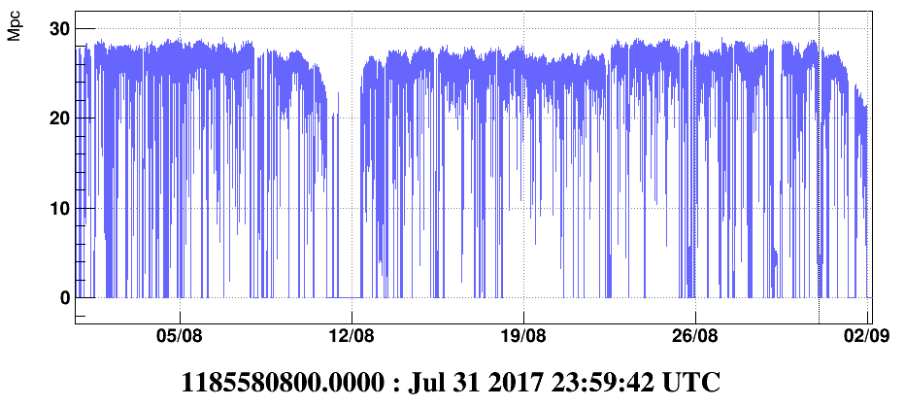
Fig 1: BNS range computed online (with FFTs of 2s) during O2

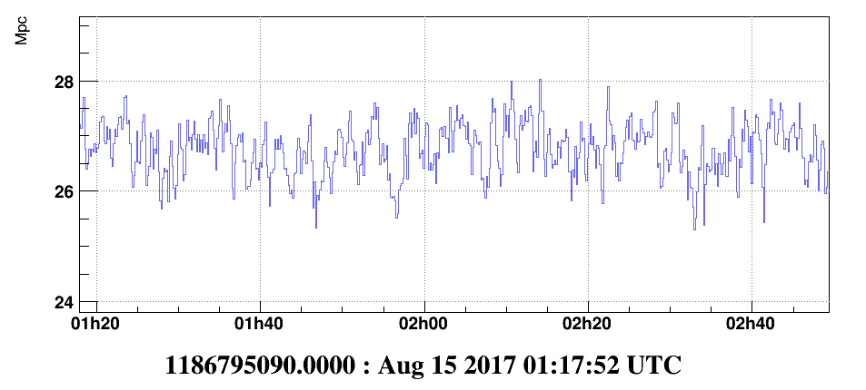
Fig 2: BNS range around its maximum value

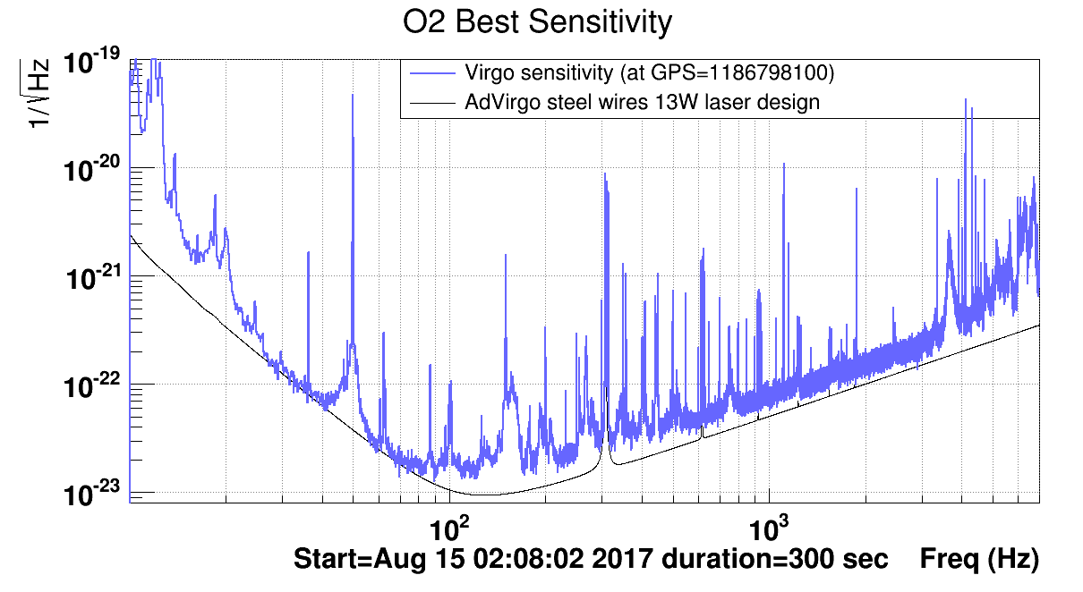
Fig 2: Best sensitivity curve over O2, computed around the time of the maximum BNS range (28 Mpc). Black curve is the design sensitivity of Advanced Virgo computed for the O2 configuration.

Sensitivity and BNS range for O3
The O3 run was made of two periods O3a (Apr 1 2019 to Sep 31 2019) and O3b (Nov 1 2019 to March 27 2020). Between those two periods, a commissioning period with improvements on the interferometer, allowed to improve the sensitivity.

The h(t) values during O3a+O3b, reconstructed online or reprocessed, were produced using FFTs of 8 sec.

The BNS range values during O3a+O3b were computed using FFTs over 2s of the channel Hrec_hoft_20000Hz and were sampled at 0.25 Hz. The use of FFTs of 2s made the channel Hrec_Range_BNS underestimated by about 5% with respect to the genuine BNS range (see p.13 of [4]).

Figure 4 shows the time evolution over O3a and O3b of this underestimated BNS range.

The maximum value over O3a was 52 Mpc, around Apr 25 2019 02:10:00 UTC (fig. 5).
The FFT of Hrec_hoft_20000Hz around this time gives the best O3a sensitivity (fig. 6).

The maximum value during O3b was 61 Mpc, around Feb 8 2020 02:10:00 UTC (fig. 7).
The FFT of Hrec_hoft_20000Hz around this time gives the best O3b sensitivity (fig. 8).

Best sensitivity curve and BNS range values for O3a and O3b can be found in a text file, in a ROOT file and in a png file, associated to this document, or in the web page [3].

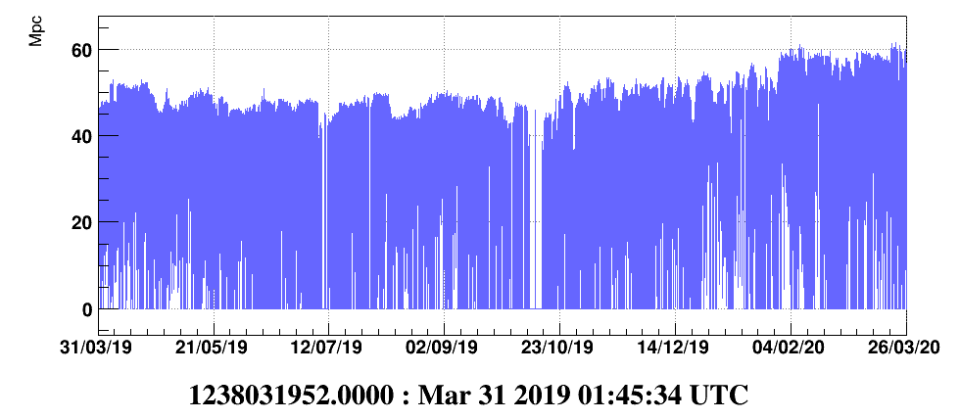
Fig 4: BNS range computed online (with FFTs of 2s) during O3a+O3b

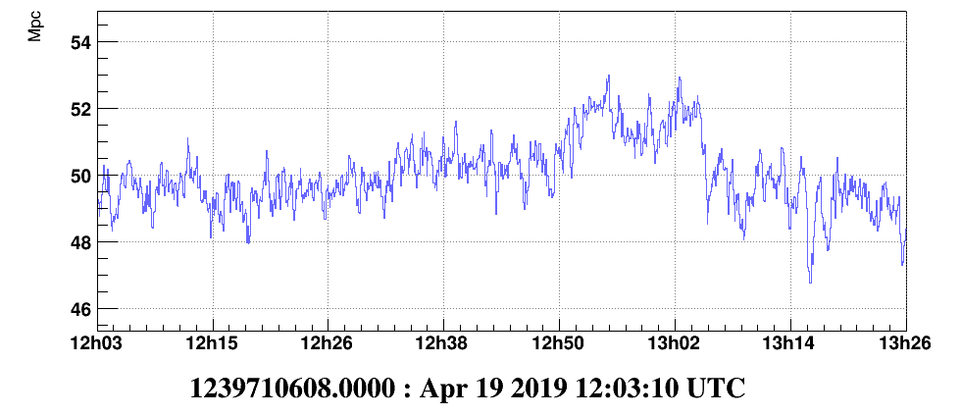
Fig 5: BNS range around its maximum during O3a

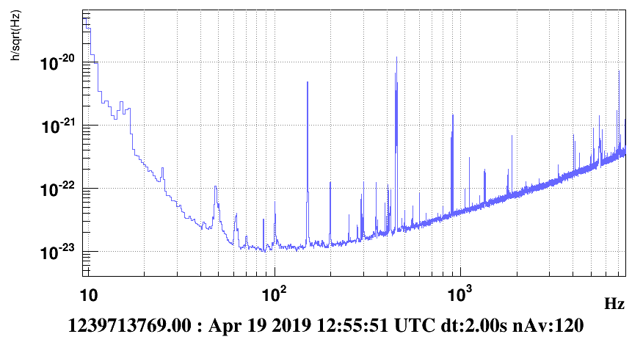
Fig 6: Best sensitivity curve for O3a, computed around the time of the maximum BNS range (52 Mpc)

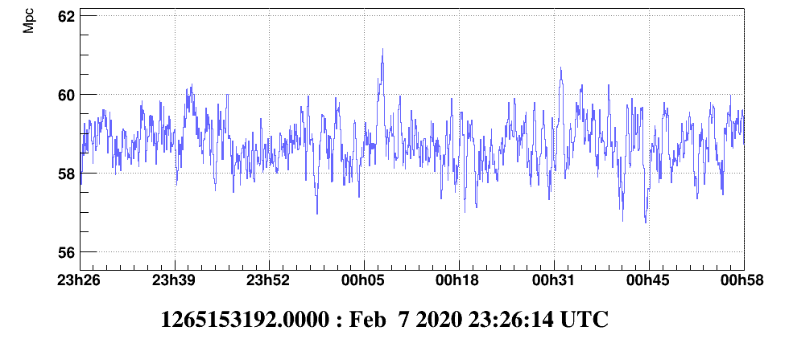
Fig 7: BNS range around its maximum during O3b

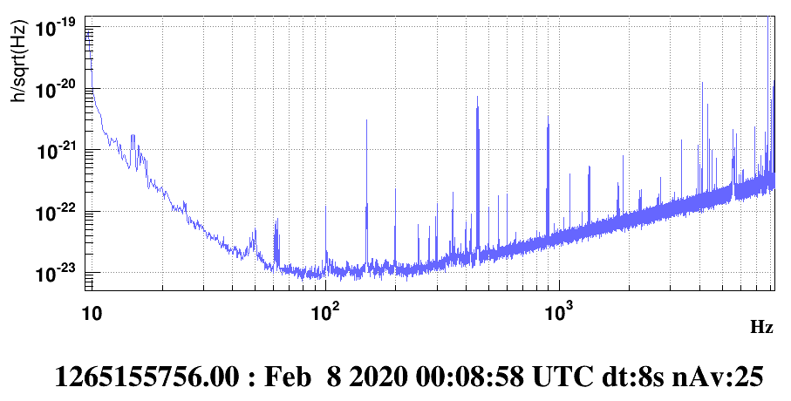
Fig 6: Best sensitivity curve for O3b, computed around the time of the maximum BNS range (61 Mpc)

History of sensitivity
Fig. 7 shows the O2, O3a and O3b best sensitivities superposed, where can be observed the improvement at high frequency, mainly due to laser power increase and frequency-independent squeezing, and the improvement at low frequency mainly due to the use of monolithic suspensions in O3 instead of steel wires in O2.
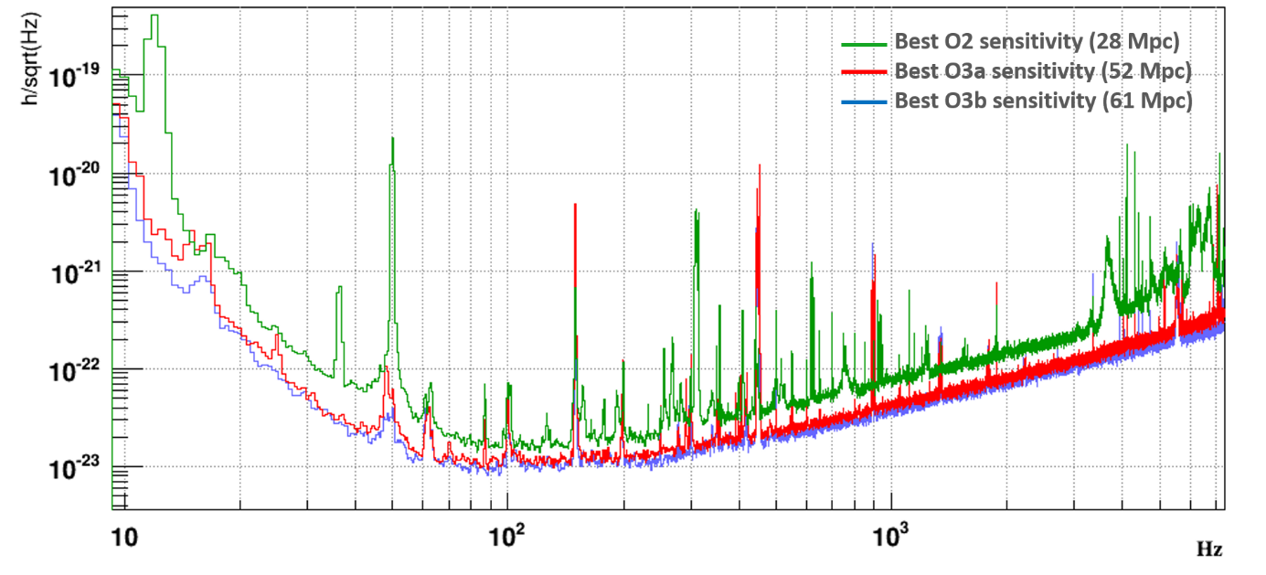
Fig 7: Superposition of the O2, O3a and O3b sensitivities

Fig. 8 shows the sensitivity improvements since the Virgo first observation run VSR1 in 2007. Various changes of the detector components and noise reduction thanks to commissioning can explain the history of sensitivity shown on this plot.
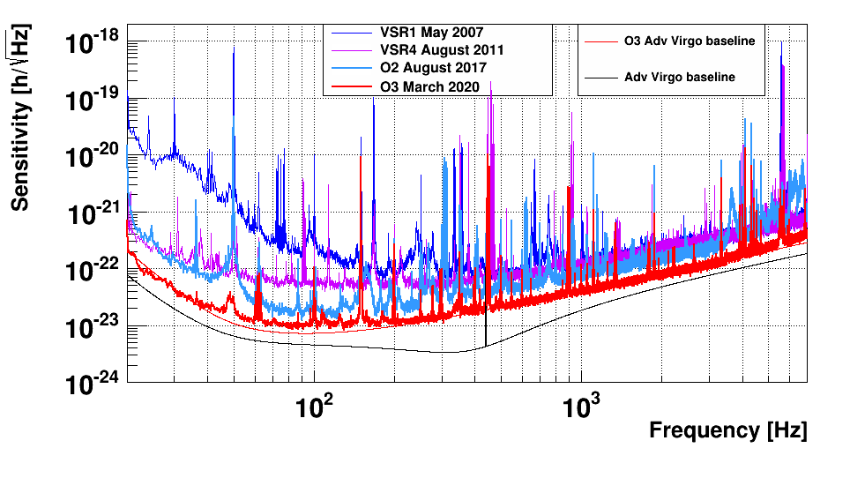
Fig 8: Superposition of the Virgo and Advanced Virgo sensitivity curves since 2007.

Bibliography
[1] Calibration of Advanced Virgo and Reconstruction of the Gravitational Wave Signal h(t) during the Observing Run O2, arXiv:1807.03275v2 [gr-qc]
[2] Calibration of Advanced Virgo and reconstruction of detector strain h(t) during the Observing Run O3, arXiv:2107.03294v2 [gr-qc]
[2] https://scientists.virgo-gw.eu/DataAnalysis/Calibration/Sensitivity
[3] Hrec package documentation, VIR-0590A-20, https://tds.virgo-gw.eu/ql/?c=15715
[5] https://www.gw-openscience.org

