Testing the Magnetic Fields Produced From Twisted Wires

Daniel Vander-Hyde¹,
¹(California State University, Fullerton), 800 N. State College Blvd., Fullerton, CA 92831-3599

Abstract
Virgo, the gravitational wave detector in Cascina, Italy, has encountered a problem with the interference of short duration magnetic field disturbances known as transients with the use of high voltage power cables. In this paper, investigations into mitigation methods such as the proposal of using twisted wire cables has been measured experimentally and the results as well as the setup of said experiment are explained. Changes may be implemented in Advanced Virgo before the next science run, if the results show a reduction in magnetic field amplitude by a significant amount.

Introduction
The Italian Electricity company (ENEL) provides AC electric power to Virgo at a frequency of 50 Hz, a 15kV amplitude, and in three phases. This power is transported to the Virgo site where it is decreased to 400V AC power in three phases and is used to feed most of the operating machinery incorporated into the Virgo Infrastructure (such as air conditioners and air compressors). This power supply, known as the Interruptible Power Supply (IPS), is subject to potential short interruptions (i.e. power outage). In addition, the Uninterrupted power generators (UPS) which are charged by the IPS power supply and are used to power the detector electronics (delicate “loads”). The transmission of this three-phase power supply, throughout Virgo, is done by the use of five-wire cables (see (Figure 1)). Magnetic transients are produced from the inrush current generated by the machinery incorporated in the Virgo infrastructure, leading to a large and short-lived magnetic field. These magnetic fields can couple to the magnetic actuators attached to mirrors, creating an unwanted disturbance into the interferometer output signal.

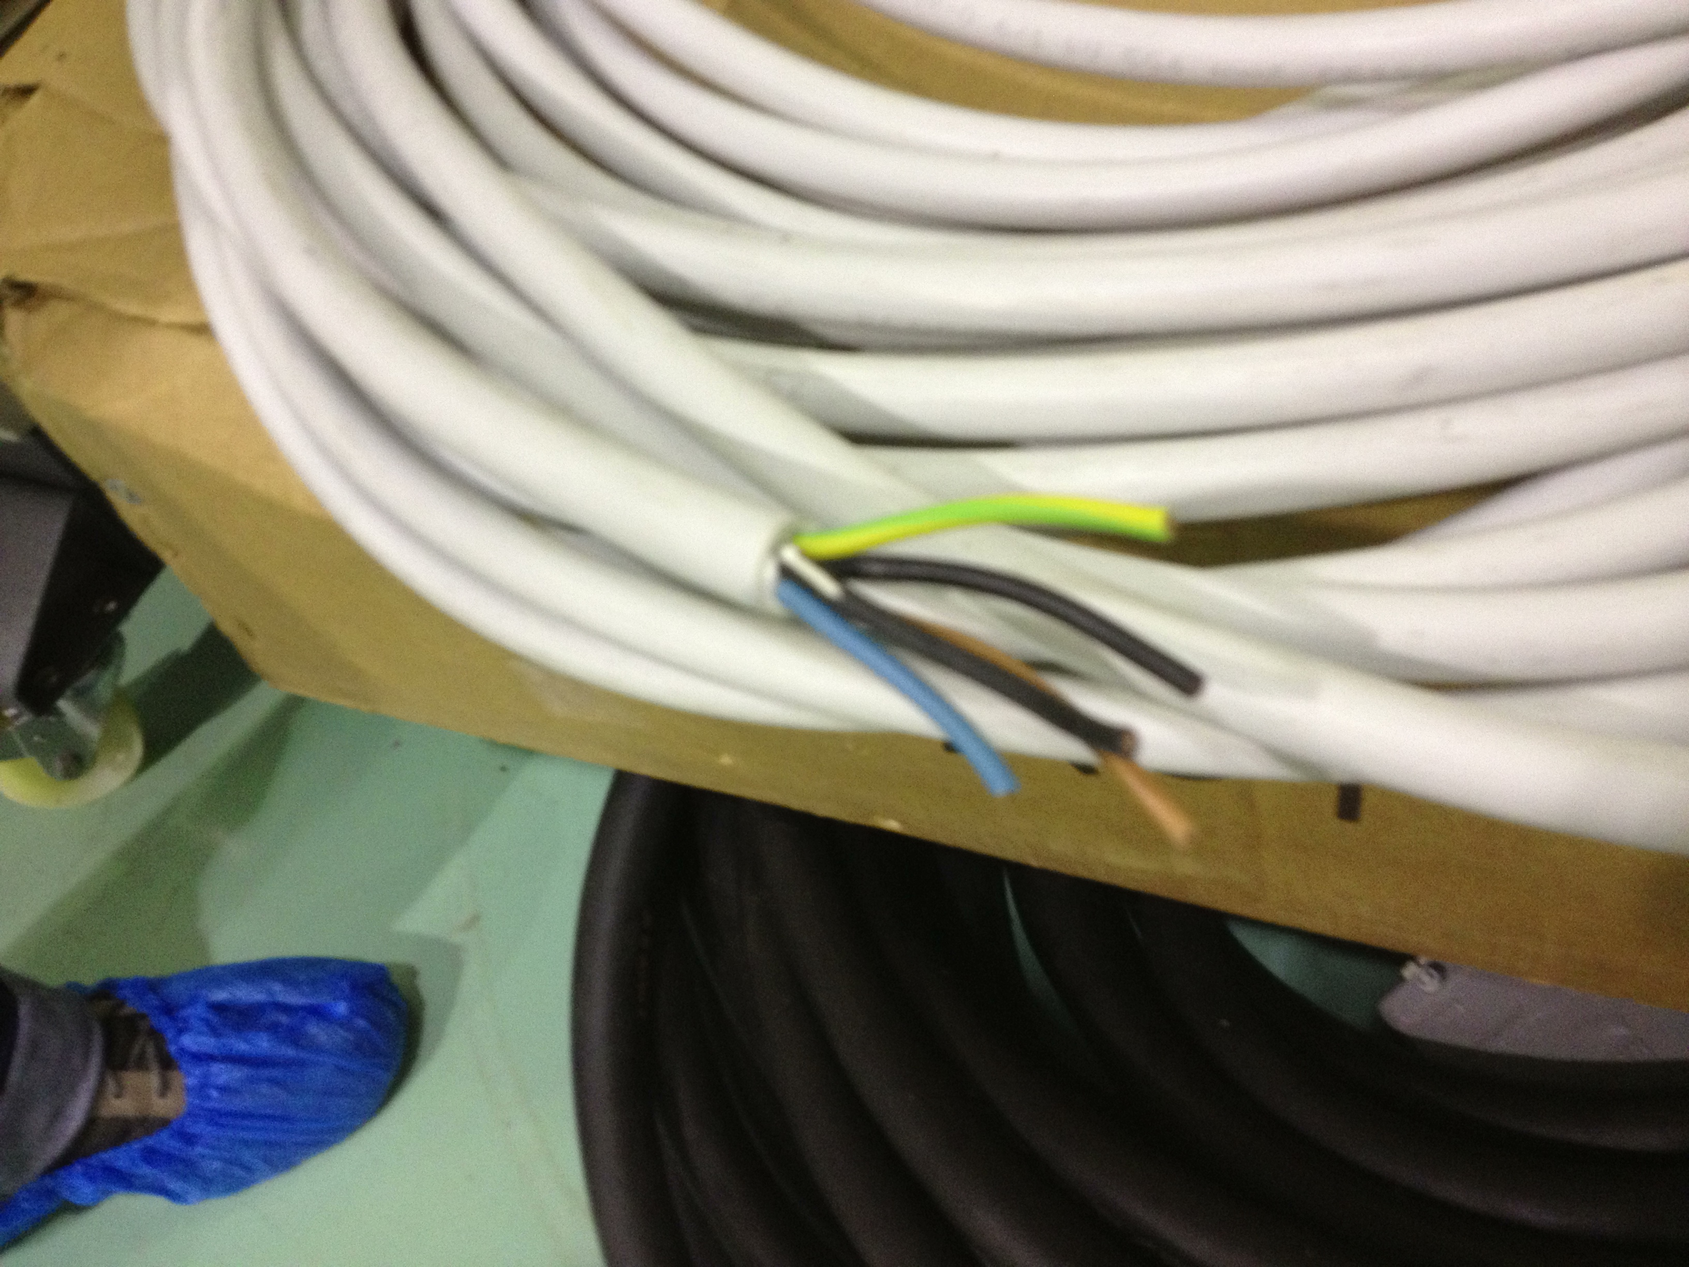

(Figure 1) These wires contained in the high voltage power cables are used to power most of the Virgo infrastructure. Three of the cables are used to transmit the three-phase current while the fourth acts as a “neutral” wire sending a reverse current whose amplitude in time is the sum of the three phases while a fifth wire acts as ground.

Two methods have been proposed in order to reduce the influence of the magnetic fields produced by these cables: increase the distance of the cables from the interferometer’s optics and/or adopt “twisted” cables (i.e. cables where the 3 phase wires are around the neutral wire) [1]. By the Biot-Savart law the magnetic field generated by one current-carrying, infinitely long, and parallel wire falls off as the inverse of the distance, therefore, moving these cables further away is guaranteed to decrease the field as well as the coupling by that factor.
The high voltage cables used at Virgo contain five cables, three of which transmit three phases of current while the other is neutral and the fifth is ground. (see (Figure 1)). In order to properly assess the magnitude of reduction by twisting the wires, a small experiment was conducted comparing the magnetic noise emission of a “standard” cable containing of a pair of parallel wires and a cable containing a pair of twisted wires.

Experimental Setup and Methods
The experiment consists of the measurement the magnetic field intensity from each one of the two cables, with a magnetometer, as the distance increases. This should give a proper estimate by what factor the twisted wires decrease the fall-off rate as well as the average magnitude difference. The equipment used in said experiment is:
- A signal generator
- A power amplifier
- A 10 m standard cable (2 X 1.5mm² – 3182Y – H05VV – F) (from inspection this cable is loosely twisted with a pitch of 17 cm)
- A 10m twisted cable (Belden, mod.8471 16 AWG, 1.5mm² twisted pair) (measured pitch: 5 cm)
- 10 Ohm resistor (ARCOL HS50), 50W and 100ppm/°C
- A Digital Multimeter
- An Onosokki CF-3650 – Portable Four Channel FFT analyzer
- A Triaxial Magnetic Field Sensor FL3-100 (Stefan Mayer Instruments) (measuring range ±100μT DC to 2kHz, sensitivity 10⁻⁴ V/nT, noise 5pT/sqrt (Hz) at 10Hz)
A picture of the setup can be seen in (Figure 2)
Primary tests were done (i.e. stability of the resistance from the resistor when operating at hot temperatures and establishing a radial span of the interfering magnetic field from the power amplifier) in order to reassure that the equipment used would not taint the results.
The aforementioned equipment was setup in a specific configuration as displayed by the (Figure 4) schematic. The twisted and “untwisted” cables were both implemented into this system, and were both tested, individually, with the same configurations as well as the same environment with the intention of making a proper comparison.
This setup was limited by:
- The need for the wires to return to the spectrum analyzer placed on the experimental bench. This will result in an unavoidable plateau in the data
- Background noise, specifically magnetic fields with a frequency at 50Hz, produced from the surrounding environment such as cables within the nearby building, and high powered machinery.
To tackle the first issue, a relatively large experimental area was used so as to better reproduce the behavior of theoretical infinite wire pairs. In order to differentiate the experimental signal from the background noise sources a continuous sinusoidal signal at 103 Hz. The Voltage was set to 10 Volts so that with the 10-Ohm resistance lead to a 1-A current. The parameters on the Onosokki display were FFT amplitude spectra of each single magnetic component. The sampling frequency was set at 400Hz, the shown frequency spectrum range was 0 to 200 Hz and the amplitude scale set in units of decibel Volts (dBV). Each spectrum was made out of 16,384 samples, which at a sampling rate of 400Hz makes a bin width of the FFT spectrum (i.e. “resolution”) of .025 Hz. There are three of these plots due to the magnetometer’s readout of the magnetic field at each of the three axes. When current is flowing through the circuit, the Onosokki naturally should display a spike at 103 Hz on all three plots. An example plot can be seen in (Figure 3) The magnitude of these peaks located at this frequency are averaged over 100 seconds and then documented as the magnetometer is moved away from the wires in five-centimeter increments until the one meter mark. After, it was measured in ten-centimeter increments until it reached the final distance of two meters.
The amplitude measurements, recorded in dBV, are then converted to nano-Tesla dividing by the magnetometer conversion factor of 10⁻⁴ V/nT. The Magnetic Field amplitudes for each component are collected where they are used after to calculate the total magnetic field, which is equal to the square root of the sum of the squares. Data is then plotted (via MatLab) on a Distance vs. Magnetic Field Amplitude plot (Figure 4).

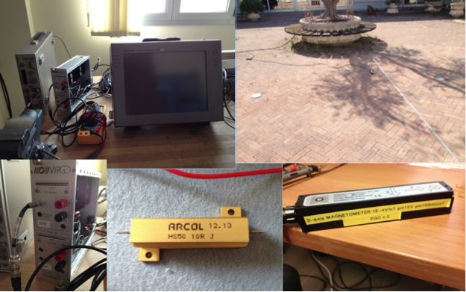
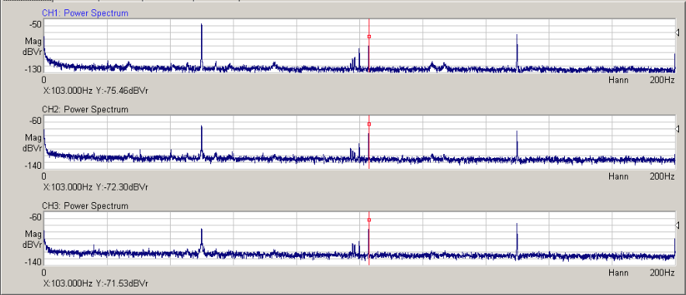
(Figure 2) (a) The experimental bench where the magnetic field values were recorded. Starting from the far left to the right is the Signal Generator, the Power Amplifier, the Voltmeter/ Ammeter/Resistor (b) The wires and magnetometer were placed outdoors in a relatively open area, offering better results. There was a one-centimeter gap in between the two wires, therefore two separate sets of measurements were performed for each wire to reduce the error. (c) The used power amplifier (d) The ARCOL HS50 10 Ohm resistor attached to the circuit. (e) The 3-axis Magnetometer used in this experiment (can be seen in (b))
(e)
(d)
(c)
(b)
(a)

(Figure 3) Example plots of Frequency vs. dBV amplitude for the x, y and z coordinates (from top to bottom) where the dBV amplitude is proportional to the magnetic field amplitude. The red line and dot are centered at the frequency of interest (103 Hz). This is a measurement of the magnetic field emitted by the twisted wires at a one-meter distance and averaged over a 100 second time interval.

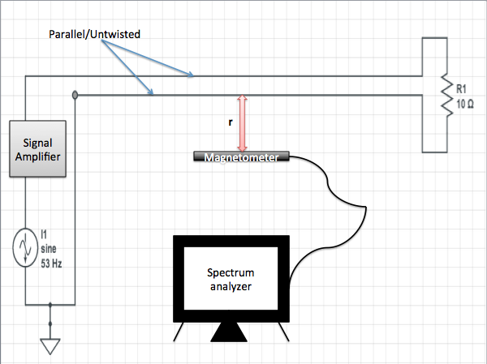

(Figure 4) A schematic of the experimental setup where r is the distance of the magnetometer from the parallel or twisted wires. This diagram shows the setup for two parallel wires but also holds true for the twisted diagram, only that the two indicated parallel wires twist before connecting to the resistor.

Results
From what can be seen in (Figure 4), the falloff rate of emitted B-field intensity is about equal for both cables and proportional r^(-3) (see (Figure 5)), but the magnetic field magnitude reduced in amplitude by a factor of 10. The loosely twisted nature of the ““untwisted”” wire can explain the equality in the falloff rate. The supplemental data table for these plots is available in (Table 1) and (Table II) in the Appendix. The plateau at the one meter point can be attributed to the stray magnetic fields produced by the returning wires.

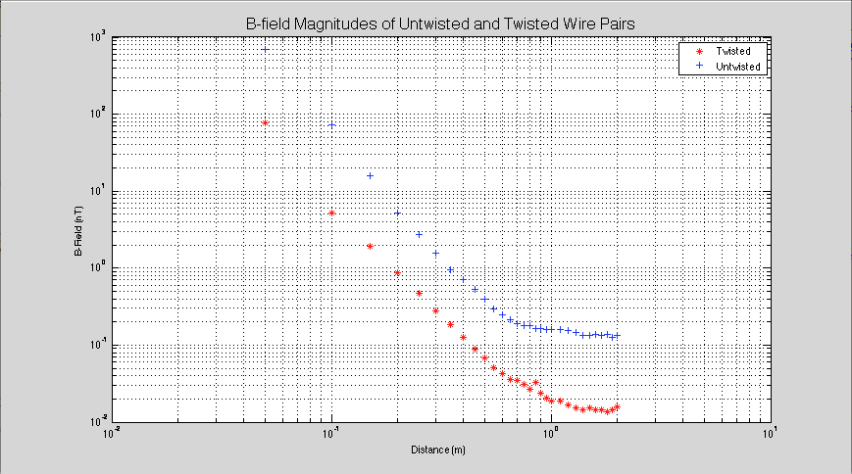
(Figure 4) A plot of the data in (Table I) and (Table 2) which can be found in the Appendix

Conclusion
These results give a good indication that implementing this solution with the IPS and UPS cables can potentially reduce the presence of magnetic transients in the Dark Fringe. The system that was measured was a two-wire and single-phase cable. Indeed, Virgo adopts a five-wire three-phase cable. But there is evidence that a similar mitigation factor can be obtained for a 3-phase cable adopting a twisting geometry in which single-phase wires form a 120° shifted helix around the neutral wire at the center [1]. Whether it be the use of twisted cables, increasing distance, or both, there is much need to mitigate this noise so that the upcoming Advanced Virgo science run can decrease the overall dead time that these transients create and give Virgo a higher sensitivity for gravitational wave detection.

Acknowledgements
This project was funded by: the National Science Foundation through the University of Florida’s Gravitational Wave physics IREU program as well as the Istituto Nazionale di Fisica Nucleare (INFN), the University of Pisa. The authors gratefully acknowledge the support of the United States National Science Foundation for the construction and operation of the LIGO Laboratory, the Science and Technology Facilities Council of the United Kingdom, the Max–Planck–Society, and the State of Niedersachsen/Germany for support of the construction and operation of the GEO600 detector, and the Italian INFN and the French Centre National de la Recherche Scientifique for the construction and operation of the Virgo detector. The authors also gratefully acknowledge the support of the research by these agencies and by the Australian Research Council, the International Science Linkages program of the Commonwealth of Australia, the Council of Scientific and Industrial Research of India, the Istituto Nazionale di Fisica Nucleare of Italy, the Spanish Ministerio de Economía y Competitividad, the Conselleria d’Economia Hisenda i Innovació of the Govern de les Illes Balears, the Foundation for Fundamental Research on Matter supported by the Netherlands Organisation for Scientific Research, the Polish Ministry of Science and Higher Education, the FOCUS Programme of Foundation for Polish Science, the Royal Society, the Scottish Funding Council, the Scottish Universities Physics Alliance, The National Aeronautics and Space Administration, the Carnegie Trust, the Leverhulme Trust, the David and Lucile Packard Foundation, the Research Corporation, and the Alfred P Sloan Foundation.

Reference

- Chien-Feng Yang, Gordon G. Lai, Mitigation of magnetic field using three-phase four-wire twisted cables, Wiley Online Library (2011)

Appendix

Distance (m) | Magnetic Field (X-component) (nT ) | Magnetic Field (Y-component) (nT ) | Magnetic Field (Z-component) (nT ) | Total Magnitude of B-field due to TWISTED WIRES (nT)
0.05 | 61.58855291 | 6.737518955 | 45.34192978 | 76.77522131
0.1 | 2.429405442 | 3.155004623 | 3.415859507 | 5.24634741
0.15 | 0.048584753 | 1.125900469 | 1.563147643 | 1.927029553
0.2 | 0.157942861 | 0.513452178 | 0.672976656 | 0.861090393
0.25 | 0.146892628 | 0.292415238 | 0.337675849 | 0.470222388
0.3 | 0.109774129 | 0.177010896 | 0.180301774 | 0.27548493
0.35 | 0.088920112 | 0.12246162 | 0.105681751 | 0.184586747
0.4 | 0.067142885 | 0.085113804 | 0.063679552 | 0.125728326
0.45 | 0.052059501 | 0.05984116 | 0.038949331 | 0.088364056
0.5 | 0.039673453 | 0.049431069 | 0.026822546 | 0.068824868
0.55 | 0.031732187 | 0.036559479 | 0.01733804 | 0.051421151
0.6 | 0.026151704 | 0.031045596 | 0.013819744 | 0.042880368
0.65 | 0.022542392 | 0.025118864 | 0.012632811 | 0.036037546
0.7 | 0.019701532 | 0.026977394 | 0.008963962 | 0.034587321
0.75 | 0.017599487 | 0.023254125 | 0.009026097 | 0.030528129
0.8 | 0.015922087 | 0.020417379 | 0.007612021 | 0.026987499
0.85 | 0.012203938 | 0.019098533 | 0.024126815 | 0.033102768
0.9 | 0.013963684 | 0.016255488 | 0.009571941 | 0.023470138
0.95 | 0.010174194 | 0.015867189 | 0.008719669 | 0.020768113
1 | 1.00346E-06 | 0.016538648 | 0.00887156 | 0.01876783
1.1 | 0.010764652 | 0.014060475 | 0.006011737 | 0.018700687
1.2 | 0.008943345 | 0.012331048 | 0.007030723 | 0.016777045
1.3 | 0.007153194 | 0.011402498 | 0.007294575 | 0.015309996
1.4 | 0.007906786 | 0.010739894 | 0.005834451 | 0.014556903
1.5 | 0.005069907 | 0.010889301 | 0.009549926 | 0.01534542
1.6 | 0.005767665 | 0.010069317 | 0.008308067 | 0.014271688
1.7 | 0.007112135 | 0.008830799 | 0.008830799 | 0.014371795
1.8 | 0.00561048 | 0.010678248 | 0.006151769 | 0.013540558
1.9 | 0.00712853 | 0.009036495 | 0.008482034 | 0.01429752
2 | 0.009397233 | 0.009204496 | 0.008669619 | 0.015754143
(Table I) This data was collected and calculated from measuring the dBV amplitudes of the Magnetic fields from twisted wires. The first and last columns represent the plotted data while he other three columns are the individual magnetic field contributions that lie on the specified axes. The last column represents the total B-field amplitude, which is calculated as the square root of the sum of the squares of the three components. The data is plotted in (Figure 4) as blue crosses

Distance (m) | Magnetic Field (X-component) (nT ) | Magnetic Field (Y-component) (nT ) | Magnetic Field (Z-component) (nT ) | Total Magnitude of B-field due to “UNTWISTED” WIRES (nT)
0.05 | 127.3503081 | 489.7788194 | 473.151259 | 692.8012029
0.1 | 0.197242274 | 54.95408739 | 48.97788194 | 73.61265886
0.15 | 1.995262315 | 13.33521432 | 7.943282347 | 15.64943281
0.2 | 1.096478196 | 4.954501908 | 1.377209469 | 5.257952026
0.25 | 0.668343918 | 2.630267992 | 0.398107171 | 2.742896757
0.3 | 0.416869383 | 1.479108388 | 0.154881662 | 1.544516117
0.35 | 0.27542287 | 0.891250938 | 0.110917482 | 0.939408686
0.4 | 0.208929613 | 0.676082975 | 0.102329299 | 0.714990251
0.45 | 0.179887092 | 0.484172368 | 0.101157945 | 0.526322313
0.5 | 0.153108746 | 0.350751874 | 0.098855309 | 0.395274003
0.55 | 0.127350308 | 0.251188643 | 0.090157114 | 0.295706173
0.6 | 0.124451461 | 0.19498446 | 0.089125094 | 0.247891888
0.65 | 0.117489755 | 0.165958691 | 0.066069345 | 0.213801983
0.7 | 0.112201845 | 0.141253754 | 0.066834392 | 0.192376488
0.75 | 0.108392691 | 0.128824955 | 0.067608298 | 0.181426918
0.8 | 0.10964782 | 0.1216186 | 0.0699842 | 0.178077277
0.85 | 0.110917482 | 0.102329299 | 0.066069345 | 0.164739587
0.9 | 0.105925373 | 0.105925373 | 0.067608298 | 0.164350999
0.95 | 0.102329299 | 0.103514217 | 0.0699842 | 0.161506244
1 | 0.102329299 | 0.103514217 | 0.067608298 | 0.160490998
1.1 | 0.098855309 | 0.103514217 | 0.066834392 | 0.157969621
1.2 | 0.098855309 | 0.1 | 0.069183097 | 0.156712071
1.3 | 0.096605088 | 0.086099375 | 0.069183097 | 0.146737679
1.4 | 0.083176377 | 0.082224265 | 0.068391165 | 0.135486128
1.5 | 0.081283052 | 0.081283052 | 0.068391165 | 0.133758067
1.6 | 0.082224265 | 0.088104887 | 0.067608298 | 0.138181702
1.7 | 0.080352612 | 0.085113804 | 0.065313055 | 0.134039909
1.8 | 0.084139514 | 0.086099375 | 0.066834392 | 0.137693123
1.9 | 0.07277798 | 0.083176377 | 0.061517687 | 0.126488616
2 | 0.075945142 | 0.087096359 | 0.063386971 | 0.131800412
(Table II) This data was collected and calculated from measuring the dBV amplitudes of the Magnetic fields from “untwisted” wires. The first and last columns represent the plotted data while he other three columns are the individual magnetic field contributions that lie on the specified axes. The data is plotted in (Figure 4) as red asterisks.

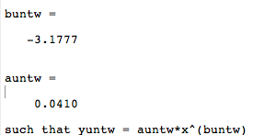
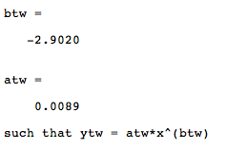

(Figure 5) These values are generated by MatLab’s “polyfit” function, using the first thirteen values on (Figure 4) establishing the true behavior of the falloff rate. The btw and buntw represent the exponential values for the exponential trend function for twisted wire and “untwisted” wire data subsets, respectively. The linearity was achieved by taking the logarithm of the x and y data subsets and plotting them on a ”loglog” graph.

