User Manual
Control software for CryoTrap test

M.Mohan

VIRGO/EG0

25 June 2012

Change Record

Version | Date | Section Affected | Reason / Remarks
V1R0 | 25 June 2012 | All | First version
V1R1 | 10 July 2012 | Figure 10:  Figure 12 | Valve states corrected from ON/OFF to OPEN/CLOSED  Clearer picture for Figure12

Table of Contents

1 Introduction 4
1.1 Purpose 4
1.2 Scope 4
1.3 Related documents 4
2 Cryotrap 5
2.1 Cryotrap Description 5
2.2 Cryotrap Control Architecture 7
3 The Tango Software bus 8
4 Connecting laptop to the cryotrap 9
5 Software User Guide 10
5.1 Tango desktop Overview 10
5.2 astor 11
5.2.1 Cryotrap Device Server 12
5.2.1.1 Cryotrap Commands 12
5.2.1.2 Cryotrap Attributes 14
5.2.1.3 Cryotrap state and status 15
5.3 synoptappli 16
5.4 mambo 17
5.5 PyTango 18
5.6 Other tango information 19
5.6.1 Access Control 19
5.6.2 Other tango tools 20
5.6.3 Documentation 20

Table of Figures

Figure 1: Picture of Cryotrap (old picture). 5
Figure 2: Diagram of Cryotrap 6
Figure 3: Architecture Overview 7
Figure 4: Tango software bus 8
Figure 5: Connecting the computer 9
Figure 6 The tango desktop view 10
Figure 7: astor 11
Figure 8: Cryotrap Command list 12
Figure 9: Safety mode generated exceptions 13
Figure 10: Cryotrap Attribute Values 14
Figure 11: States and Status values for the Cryotrap server 15
Figure 12 synoptappli Crytroptrapsynoptic.jdw 16
Figure 13: Authorisation Message 19

Introduction
Purpose
This document provides and overview of the software used to test the cryotrap and explains how to use it.
Scope
The document is designed to be used by engineers when testing the cryotrap. It provides an architectural overview and explains how to use some of the software tools available.
Related documents

[1] | J. v. d. Brand, "NIKHEF PROJECT PLAN: CRYOLINKS Cryogenic vacuum links to isolate interferometer arms for Advanced Virgo," Nikhef, National Institute for Subatomic Physics, P.O. Box 41882, Amsterdam, the Netherlands , June 18, 2010.
[2] | Mohan, "https://tds.ego-gw.it/ql/?c=8978," 27 04 2012. [Online].
[3] | Ballardin, "https://workarea.ego-gw.it/ego2/ego/itf/software/auth-only/documents-for-cryotrap," 08 02 2012. [Online].
[4] | Cavaliere, "https://workarea.ego-gw.it/ego2/virgo/advanced-virgo/vac/1st-cryotrap-test/vacuum-equipment-for-1st-test-27apr2012/CryoTrap_Control_Test.pptx/," 04 2012. [Online].
[5] | tango, "http://ftp.esrf.eu/pub/cs/tango/MAXlab/tango_training_MAX_lab.ppt," [Online].
[6] | mohan, "Updating the Cryotrap readout equipment," [Online]. Available: https://tds.ego-gw.it/ql/?c=9021.
[7] | Mohan, "A GENERAL DEVICE DRIVER SIMULATOR TO HELP COMPARE REAL," in ICALEPCS2011, Grenoble, France, Grenoble, 2011.
[8] | lal, "http://www.lal.in2p3.fr/," [Online].
[9] | "Tango Home Page," [Online]. Available: http://www.tango-controls.org/.

Cryotrap
This section gives an overview of the cryotrap and the design architecture.
Cryotrap Description
A cryotrap is used in the vacuum to trap gases and vapours by condensing them on a cold surface. In EGO’s case they are used to keep out water contaminants. [1]
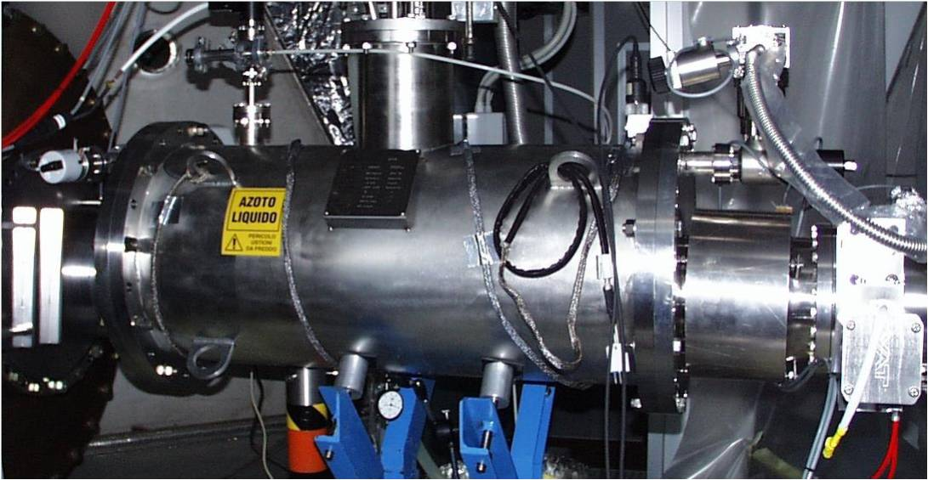
Figure 1: Picture of Cryotrap (old picture).
.
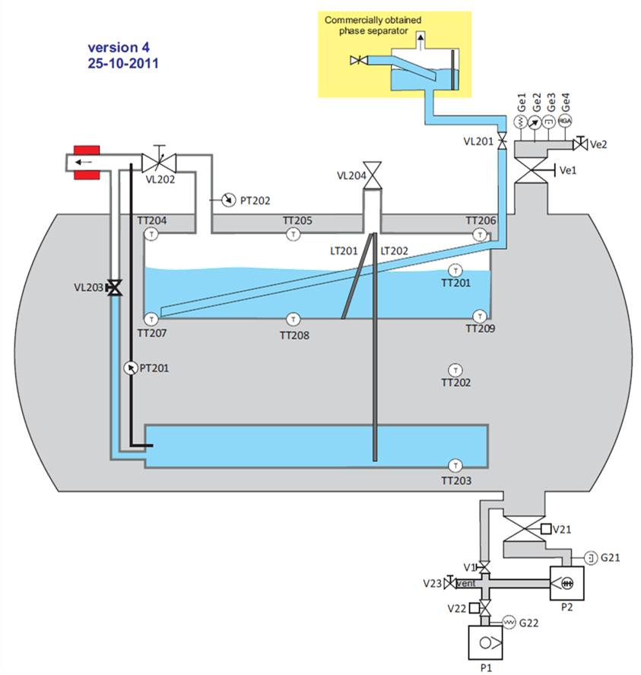
Figure 2: Diagram of Cryotrap

Cryotrap Control Architecture
The cryotrap control is based on 3 layers. An electronic layer, a plc layer and a tango software layer.

Figure 3: Architecture Overview

The control layers are
- Software layer. The software controls the cryotrap via the plc. Valves and pumps are controlled by writing to a modbus address on the plc. Temperature and states are monitored by reading from modbus addresses on the plc. [4]. Safety logic is built in to the plc to prevent users damaging the cryotrap.
- PLC Layer. The plc controls the electronics. It sets relays to open and close valves. It also reads temperature and pressure into a modbus memory area. Safety logic is built in to the plc to prevent users damaging the cryotrap. [3]. See the PLC user guide for further details. https://tds.ego-gw.it/ql/?c=9044
- Electronic Layer. These are the switches to control valves and read pressure and etc... Safety logic is built in to the electronic prevent users damaging the cryotrap. [2]

The Tango Software bus
Tango architecture uses what is referred to as a “software bus” [8]. Tango uses a device server program to read devices. The Cryotrap device server is a program which reads/writes to a plc using modbus/tcp protocol. The device server then puts the data onto the software bus where tango clients can access the data.
Several tango clients read and write to the cryotrap device server via the tango bus. Clients include a human machine interface (synoptappli), a trend recorder (mambo) and a programming interface (PyTango).

Figure 4: Tango software bus

Connecting laptop to the cryotrap
All the tango software is installed on a laptop. The laptop is connected directly to the lan port on the plc.
Note: The lan can also be connected over the internet but this means communication may be affected by network traffic. In future a separate lan port on the computer could be used for network connection [9].

Figure 5: Connecting the computer
The device server instance (Cryotrapwe) running on the laptop communicates with the plc over a lan using modbus/tcp protocol.

Software User Guide
Tango desktop Overview
At boot up the tango program to connect with the cryotrap is automatically started. Authorised users can access the control software at login. Below is the desktop view of the user “tango” who has full read/write privileges to the cryotrap. Other users will have more restricted privileges.

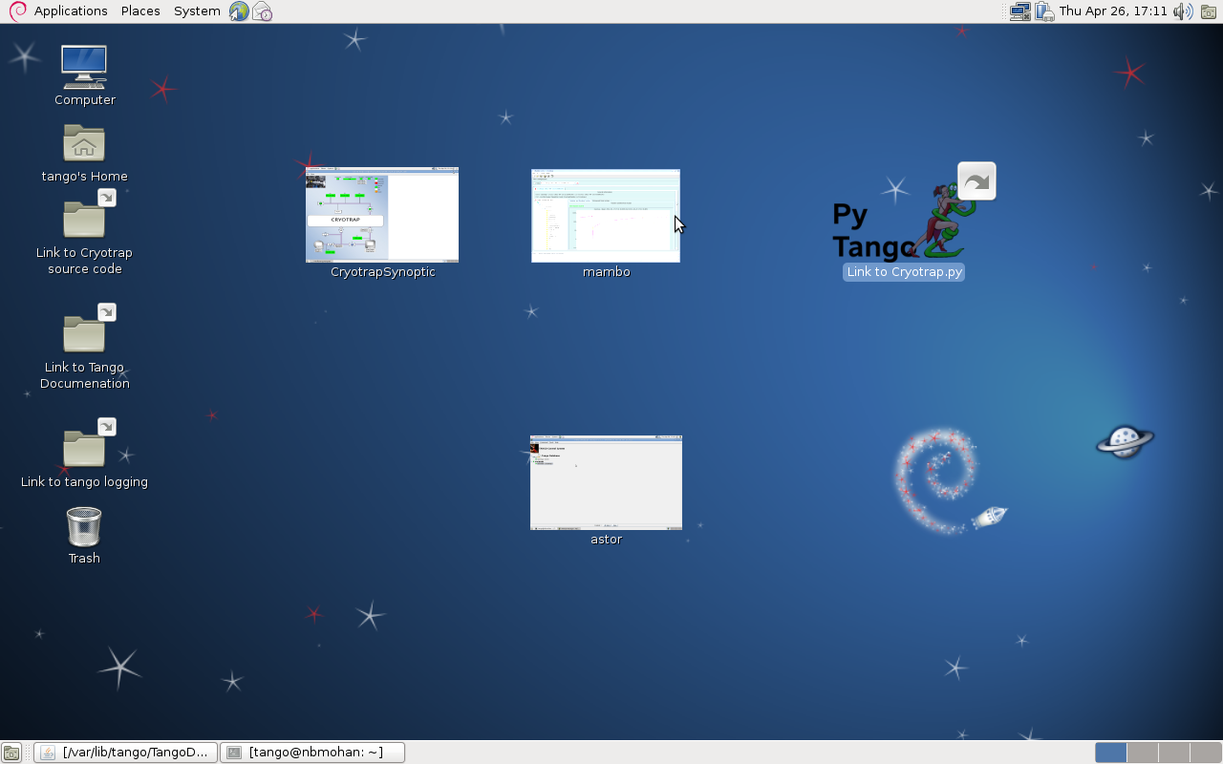
Figure 6 The tango desktop view

The desktop contains icons which launch client applications when clicked although these clients can also be launched from the command line.

astor
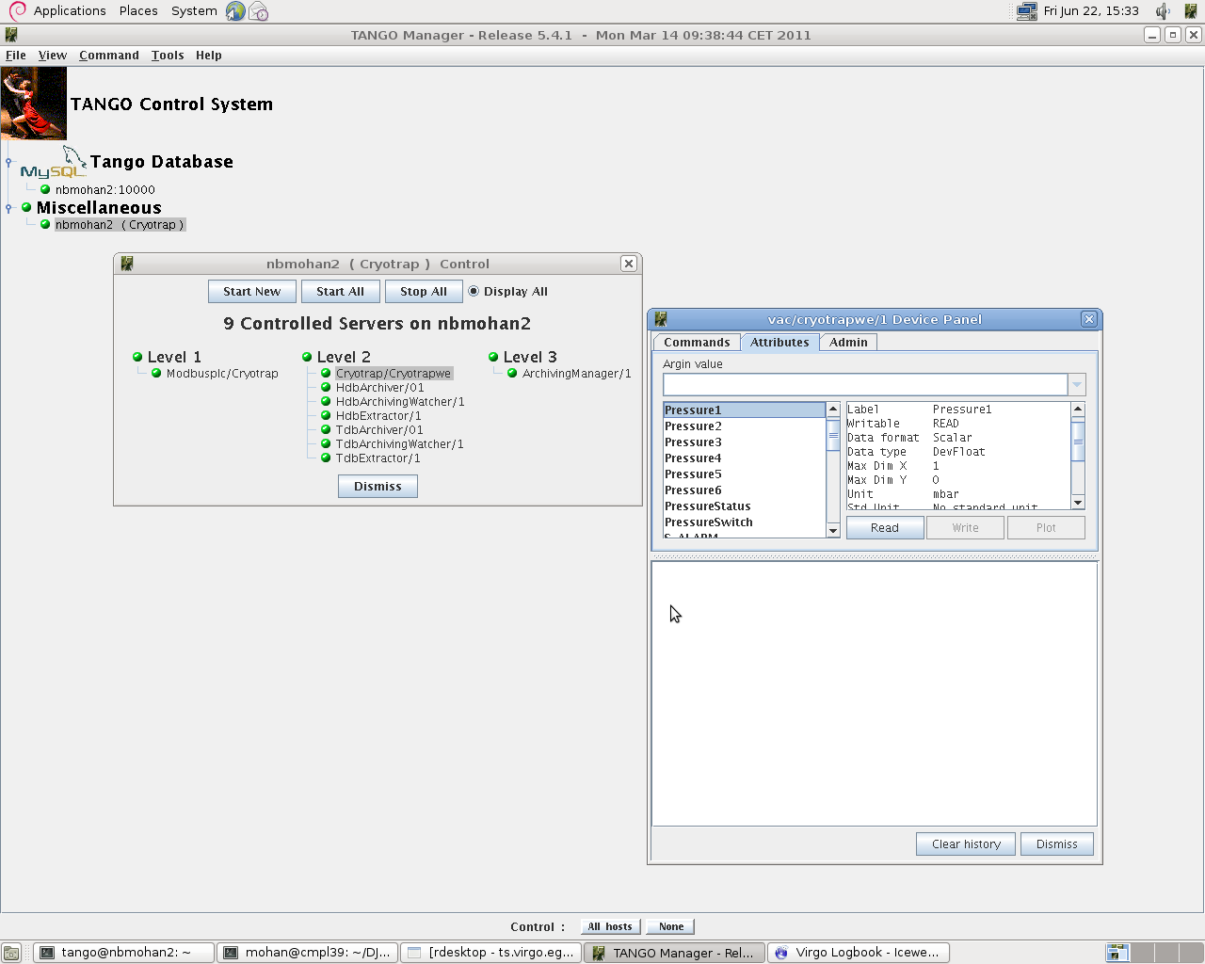
Figure 7: astor
All device servers are started automatically at boot time and astor is a tool to control the various tango device servers.

Two device servers are used to control the cryotrap
- The Modbusplc server is used to read and write to the plc using modbus/tcp protocol.
- The Cryotrap server uses the Modbusplc server to read and interpret plc values.
The other device servers shown (e.g. HdbArchiver/01) were developed by Soleil and are used by the mambo data archiving tool.
Users with appropriate access control privileges can use astor to test servers. Full documentation for astor is provided at the link below.
http://www.esrf.eu/computing/cs/tango/tango_doc/tools_doc/astor_doc/index.html
Cryotrap Device Server
The cryotrap device server reads and interprets all plc values once per second.
Commands can also be sent to the cryotrap The commands can be tested using the astor tool by right clicking the device Cryotrap/Cryotrapwe and selecting “Test Device”.

Cryotrap Commands
Listed below are commands that can be sent to the cryotrap.

Command | Meaning | Comment
Init | Initialise the Cryotrap | Automatically called at start-up
State | Get state of Cryotrap | ON or FAULT or ALARM
Status | Get status of Cryotrap | A string value showing status
StartScroll | Start the scroll pump
StopScroll | Stop the scroll pump
StartTurbo | Start the turbo pump
StopTurbo | Start the turbo pump
OpenV21 | Open valve V21
CloseV21 | Close valve V21
OpenV22 | Open valve V22
CloseV22 | Close valve V22
SafetyModeOn | Switch On Safety Mode
SafetyModeOff | Switch Off Safety Mode | ALL safety including plc and hardware is disabled. Use with care as the cryotrap can be damaged.
UpdateAttributes | Updates all attributes | This command is called once per second. Updates all values and sets the cryotrap State to ON or FAULT or ALARM
Figure 8: Cryotrap Command list

        - SafetyModeOn command
Safety Mode is on by default and is used to protect to the cryotrap. .When safety mode is ON the electromagnetic valves V21 and V22 can only be opened under certain conditions and a user may not open the valve unless those conditions are met.
An Error message will pop up telling the user the reason they cannot open a valve.

Operation Command | SafetyMode generated Exceptions
OpenV21 | Cannot open V21unless turbo_p21 is ON
OpenV21 | Cannot open V21 unless Ve1 is open
OpenV21 | Cannot open V21 if GE2>4mbar
OpenV21 | Cannot open V21 if GE1>4mbar
OpenV22 | Cannot open V22 unless scroll_p22 is ON
OpenV22 | Cannot open V22 if V1 open and Ve1 open and Pressure1 < 0.1 mbar
Figure 9: Safety mode generated exceptions

        - SafetyModeOff command
SafetyModeOff option is used for testing. When this mode is selected all hardware and software safety is turned off and exceptions above will not be generated. When safety mode is turned off the cryotrap can be damaged.
The state and status of the cryotrap is still updated every second and illegal states will cause the state to be in ALARM mode (orange).

Cryotrap Attributes
Attributes contain values to be monitored for the cryotrap. Available attributes can be viewed by clicking on the Attributes tab in Astor. As can be seen from table most attributes return a state value and the overall state and status of the cryotrap is determined from these values.
Attribute | Value returned
Pressure1 | MaxiGauge Pressure 1 in mBar (GE1)
Pressure2 | MaxiGauge Pressure 2 in mBar (GE2)
Pressure3 | MaxiGauge Pressure 3 in mBar (GE3)
Pressure4 | MaxiGauge Pressure 4 in mBar (not attached)
Pressure5 | MaxiGauge Pressure 5 in mBar (G21)
Pressure6 | MaxiGauge Pressure 6 in mBar (G22)
PressureStatus | MaxiGauge Pressure Status 1=on,2=off e.g. 1,1,1,2,1,1
PressureSwitch | ON or OFF
S_ALARM | ALARM state
S_OPEN | OPEN state
S_CLOSE | CLOSE state
S_FAULT | FAULT state
S_MOVING | MOVING state
S_ON | ON state
S_OFF | OFF state
S_UNKNOWN | UNKNOWN state
SAFETY_MODE | ON or OFF
Scroll_P22 | ON or OFF or MOVING
Turbo_P21 | ON or OFF or MOVING
State | Cryotrap state: ON or FAULT or ALARM
Status | “various values”
V1 | OPEN or CLOSE or MOVING or FAULT
V2 | OPEN or CLOSE or MOVING or FAULT
V21 | OPEN or CLOSE or MOVING or FAULT
V22 | OPEN or CLOSE or MOVING or FAULT T
V23 | OPEN or CLOSE or MOVING or FAULT
Ve1 | OPEN or CLOSE or MOVING or FAULT
Ve2 | OPEN or CLOSE or MOVING or FAULT
ModbusRegister50 | This is the value of Modbus register 50. This is an important register which is displayed for debugging purposes.
Figure 10: Cryotrap Attribute Values

Cryotrap state and status
The cryotrap attributes are updated once per second. The overall state and status of the cryotrap is determined based on these values. Three cryotrap states are possible ON or FAULT or ALARM. The status provides more detailed information. A list or cryotrap states and status is shown below.

STATE | STATUS | COMMENT
ON | ON | Operation mode
FAULT | ModbusPLC init FAULT | Modbus device server Initialisation fault
FAULT | modbus UpdateAttrib FAILED | Failure reading attributes
FAULT | modbus_device->state FAULT | Modbus device server fault
ALARM | G22>8mbar ,V21 , V22 not closed | Pressure G22 is above 8 mbar but V21 and V22 are not closed.
ALARM | GE1<0.1mbar, V1 open and V22 not closed | Pressure GE1 is less than 0.1 mbar but V1 and V22 are not closed
ALARM | PressureSwitch OFF but V22 not closed | The pressure switch is off but V22 is not closed
ALARM | Turbo_p21 not ON and V21 not closed | The turbo pump is on but V21 is not closed
ALARM | Scroll_P22 not ON and V21 not closed | The scroll pump is on but V21 is not closed
ALARM | PressureSwitch OFF but V21 not closed | The pressure switch is off but V21 is not closed
Figure 11: States and Status values for the Cryotrap server
Notes:
- Only one status message is displayed at a time. If there is more than one fault the FAULT or ALARM with highest priority will be set in status.
- All state and status are values also recorded in the log files.
- The above rules are subject to review.

synoptappli
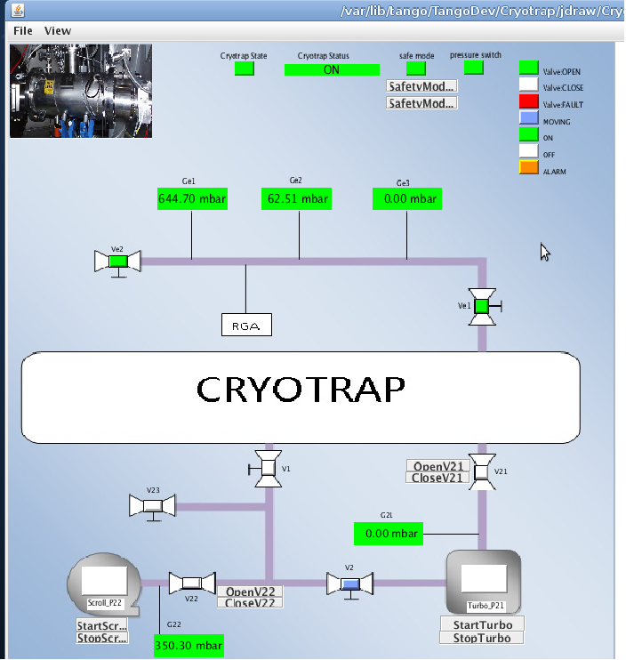
Figure 12 synoptappli Crytroptrapsynoptic.jdw

The synoptappli client provides a user friendly display of the cryotrap server.
The state and status of the cryotrap are displayed at the top.
When safety mode is on exceptions listed in Figure 9 appear as a pop up window.

mambo
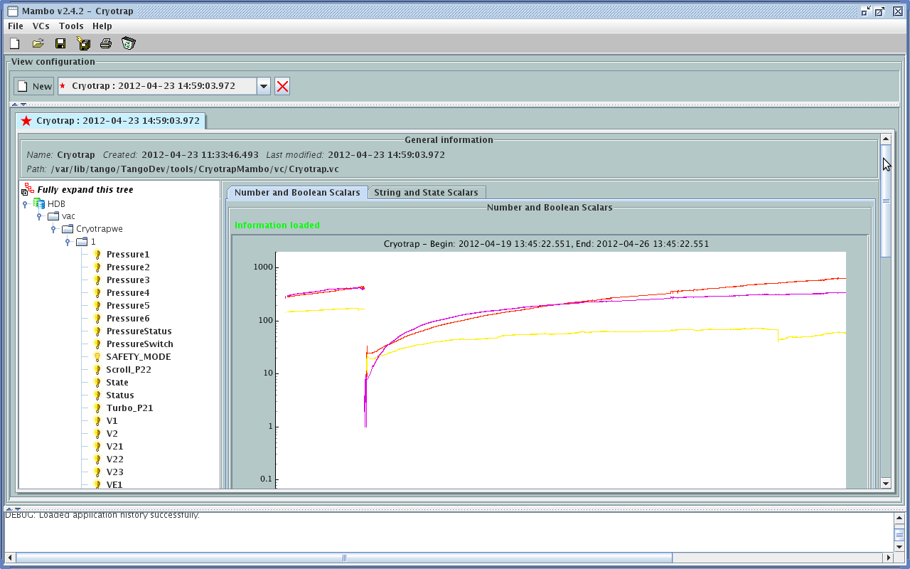

The mambo tool was developed at the Soleil synchrotron. It provides trend data information over days, months or years. The states of all attributes are recorded and the values can be exported as a table or displayed in graph form.

PyTango
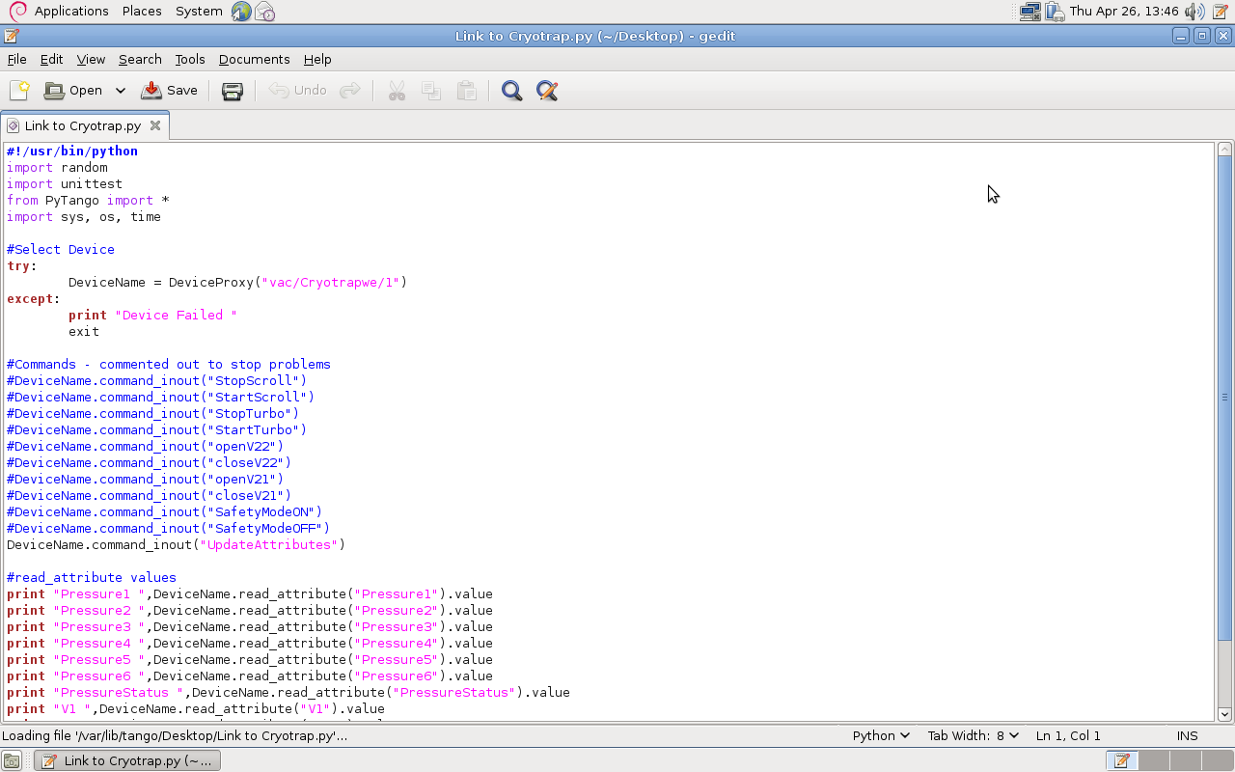

A link on the desktop provides an example program to access the Cryotrap values using the tango python interface PyTango. PyTango is described in the list below.
http://www.tango-controls.org/static/PyTango/latest/doc/html/index.html

Two other example programs are below.

Program 1: Open valve v22

DeviceName = DeviceProxy("vac/Cryotrapwe/1")
DeviceName.command_inout("openV22")

Program2: Print state of valve v22

DeviceName = DeviceProxy("vac/Cryotrapwe/1")
print "V22 ",DeviceName.read_attribute("V22").value

Other tango information
Access Control
The user “tango” has full access to the cryotrap but other users have limited access.
Another user will see the same interface but when a command is issued they are informed that they are not authorised for some commands (depending on authorisation allowed)..
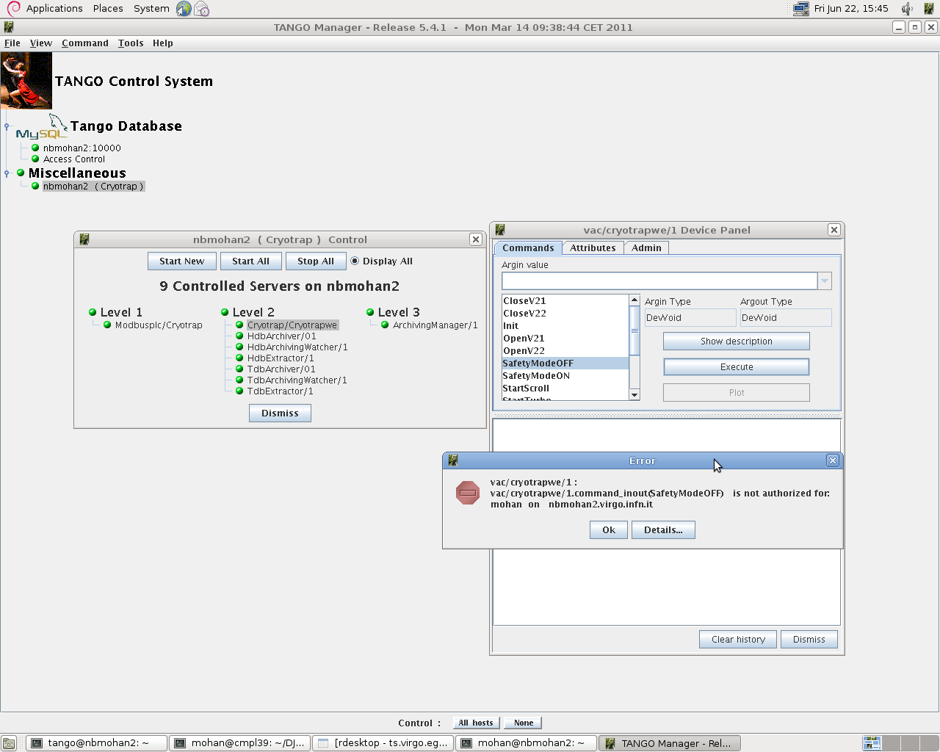
Figure 13: Authorisation Message

Other tango tools
The clients described above synoptappli, mambo and PyTango display the Cryotrap server information in different ways. There are also many other tools available for tango such as…
logviewer – to display logs
atkmoni – to view graphs
etc…

Documentation
Information on tango is available at
http://www.tango-controls.org/
Documentation for tango tools is available at…
http://www.tango-controls.org/Documents/tools

