TANGO Software testing at Schio on the Cryotraps

Martin Mohan, Antonio Pasqualetti, Giulio Ballardin.

VIRGO/EG0

07 April 2014

Change Record

Version | Date | Section Affected | Reason / Remarks
V1R0 | 04 March 2014 | All | First version
V1R1 | 07 April 2014 | 4,5 | Updated to show measurement after bake-out.
V1R2 | 08 April 2014 | Title | Changed title to reflect this is more software testing.

Table of Contents
1 Introduction 3
1.1 Purpose of Tests 3
2 Software for testing the cryotrap 4
3 Measurement Results 5
3.1 Measurement 3 days (31/01/2014 to 03/02/2014) 5
3.2 Measurement 3 weeks (03/03/2014 to 26/03/2014) 6
3.3 Tango Server and gui 7
4 Conclusion 8

Table of Figures
Figure 1: Diagram of Cryotrap 3
Figure 2: Synoptic used to Control the cryotrap 4
Figure 4: Pressure from Friday January 3 until Monday February 3rd February (3 days) 5
Figure 5: Pressure from Monday 3rd March until Tuesday 25th of March ( 3 weeks) 6

Related Documents
[1] | Mohan, User Manual: Control Software for CryoTrap Test  https://tds.ego-gw.it/ql/?c=9045

Introduction
Purpose of Tests
We wanted to test Cryotraps and also check the TANGO software over longer periods. Testing was more awkward at Schio (VI) than at Pisa as we could not connect remotely to the factory were the Cryotraps were located and Schio is 360km from Pisa (an 8 hour round trip).

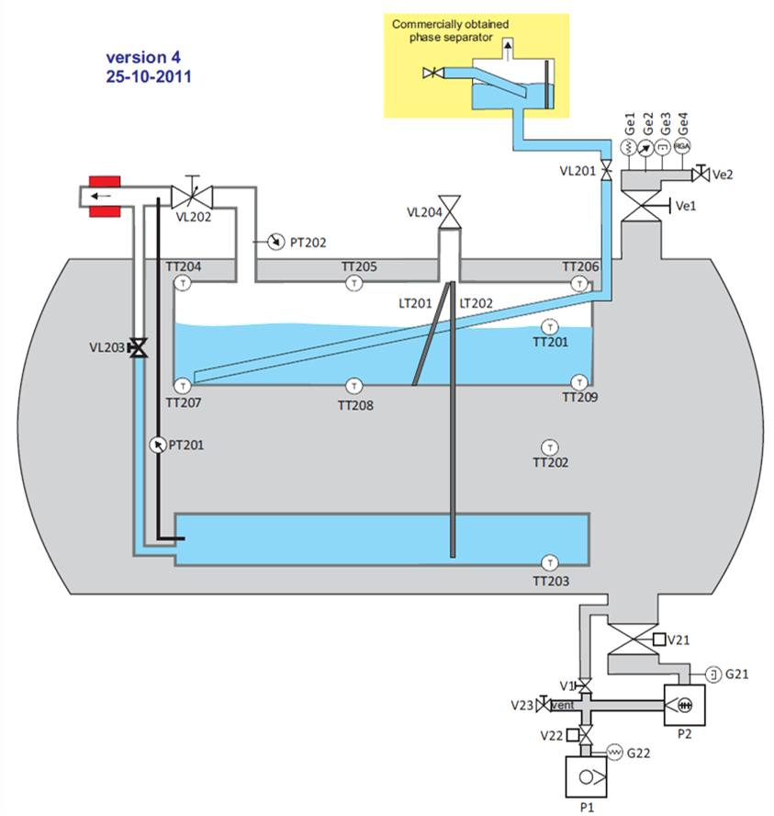
Figure 1: Diagram of Cryotrap

Software for testing the cryotrap
A TANGO test server was used to open/close valves and switch on/off pumps monitor gauges etc….A TANGO synoptic (gui) was developed to control this server and all values were archived to a Mysql database every 10 seconds using TANGO’s mambo tool. This test software is described in ref1. https://tds.ego-gw.it/ql/?c=9045

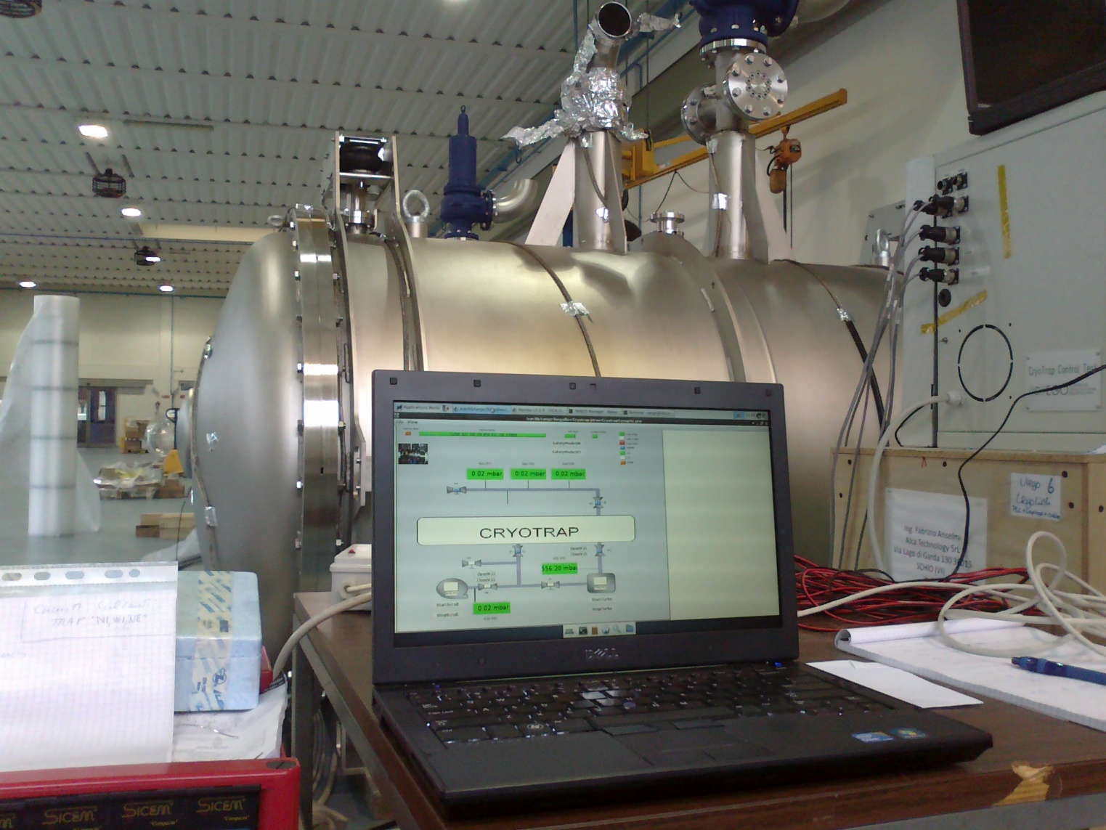
Figure 2: Synoptic used to Control the cryotrap

Measurement Results
Measurement 3 days (31/01/2014 to 03/02/2014)
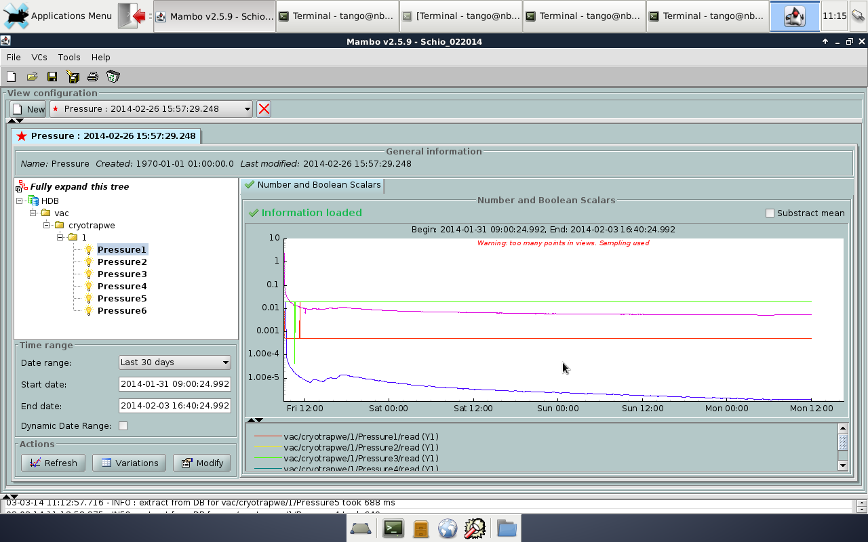
Figure 4: Pressure from Friday January 3 until Monday February 3rd February (3 days)

Measurement data stopped unexpectedly after 3 days at 12am on Monday 3rd February seemingly due to a software error. As there was no internet connection at Schio this was only discovered on the next trip.
When the cryotrap is installed at EGO if measurements stop or software fails an alarm will notify the operator.
The minimum pressure registered was 1.187e-6 mbar on P5 (G21) on Monday 3rd February at 12:00. These measurements were made before bake-out.

Measurement 3 weeks (03/03/2014 to 26/03/2014)
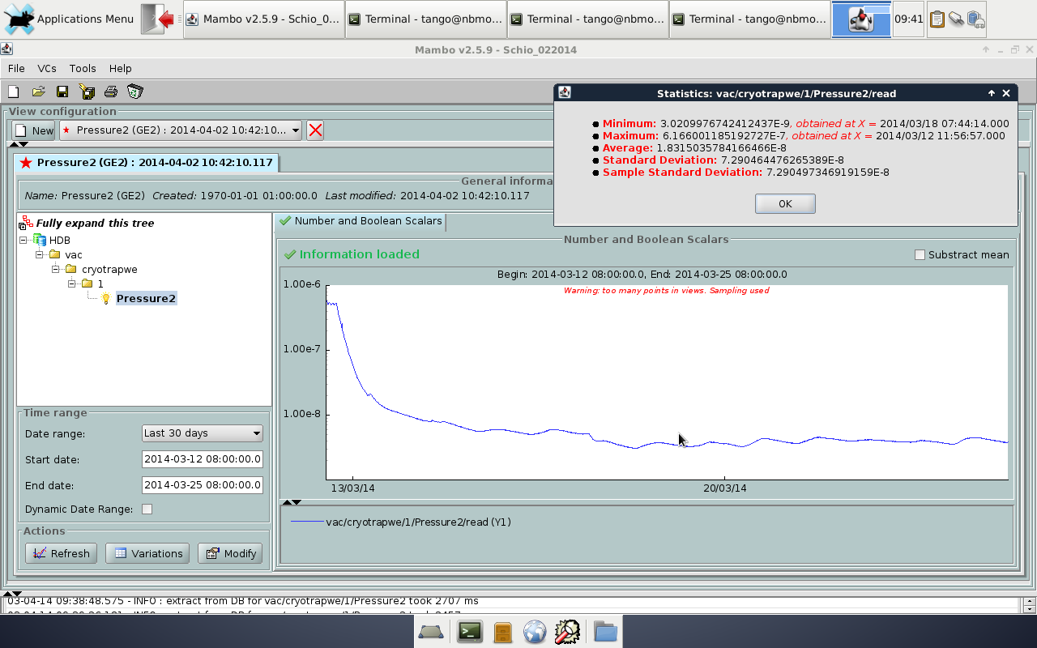
Figure 5: Pressure from Monday 3rd March until Tuesday 25th of March ( 3 weeks)

The TANGO software was updated to a later version and some improvements made. The second measurements were from 12/03/2014 to 25/03/2014. This time measurement was successful (i.e. measurement continued correctly until computer was disconnected).
The minimum pressure registered was 3.02e-9 mbar on Tuesday 18 March at 07:44. These measurements were made after bake-out on P5 (G21).

Tango Server and gui
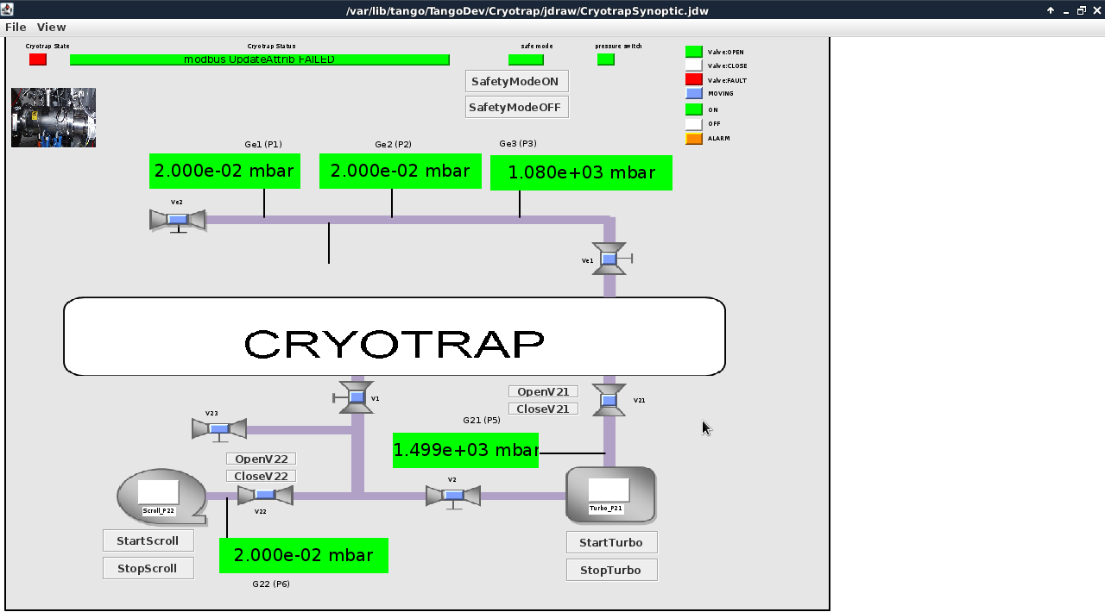
Figure 7: TANGO GUI used to control and monitor the Cryotrap

The above synoptic above was used to control the Crotrap server. This synoptic and all the other TANGO clients worked without problems.
Conclusion
The TANGO software was used to test the Cryotraps at the factory location at Schio in northern Italy. When archiving data over longer periods a problem was found but this was corrected. All the cryotrap devices were successfully monitored and controlled with TANGO tools. After bake-out a minimum pressure of 3.02e-9 mbar was registered during a 3 week measurement period.
Fine tuning of the cryotrap and its control system will be done at EGO. In contrast to testing at Schio which was done on a portable laptop the software at EGO will run on a fixed server and data will be available over the internet to engineers at EGO, LAL and Nikhef.

Gauges were swapped during test so P5 is mistakenly labelled as Pressure 2 in the graph
The Cryotrap was not attached when this snapshot was taken so values shown are not valid

