Integration of Tango and the Cryotrap Control System at EGO

Martin Mohan
VIRGO/EG0

09 March 2015

Change Record

Version | Date | Section Affected | Reason / Remarks
V1R0 | 10 March 2015 | All | DRAFT
V1R1 |  |  | .

Table of Contents
1 Introduction 3
1.1 Cryotraps at EGO 3
1.2 Cryotrap hardware controllers and modbus 4
1.3 Cryotrap setup at west-end and Tango 5
1.4 Astor client 6
2 Tango cryotrap servers for cRIO 8
2.1 cRIO performance 9
1.1.1 Archiving Data at west end (we-l1-01) 9
1.1.2 Archiving Data at north end (ne-l1-01) 10
3 Tango Integration at EGO 11
3.1 Current Situation 11
3.2 Tango Integration requirements 11
4 Conclusion 12

Table of Figures
Figure 1 Large cryotraps controlled by tango servers 3
Figure 2 Tango Clients and Servers for the cryotrap control at west-end 5
Figure 3 List of tango servers - vac/crio/we-l1-01 6
Figure 4 Controlling cRIO from tangoserver 8
Figure 5 Extract of table describing some modbus addresses for the Crio. 8
Figure 6 Data acquisition at the west end 9
Figure 7 Data acquisition at the north end 10
Related Documents
[1] | Tango Status at ego May 2014  https://tds.ego-gw.it/ql/?c=10321
[2] | Updating the Cryotrap readout equipment  https://tds.ego-gw.it/ql/?c=9021
[3] | Cool-down of the WE cryotrap on site  https://tds.ego-gw.it/ql/?c=10740
Institute Acronyms
EGO: European Gravitational Observatory, Pisa, Italy
ESRF: European Synchrotron Radiation Facility
LAL: Laboratoire de l’Accelerateur Lineaire, Paris (Orsay), France
Nikhef: National Institute for Nuclear and High energy physics, Amsterdam, NL

Introduction
This report will look at the use of Tango for control of the vacuum cryotraps at ego. Tango development for the Cryotraps can be used as a template for development of other Tango systems at EGO. Displaying the value of one attribute (TT01-CL-bot-side) on one device is used as an example of how Tango is used to monitor devices.

Cryotraps at EGO
The cryotrap is used for stopping water contamination of the vacuum tubes. Two cryotraps are already installed and another two will be installed in the near future.
- Two large cryotrap are installed. One at the west end and one the north end.
- Two large cryotraps will be installed in the central building (WI and NI).
- Two small cryotraps will be installed between the tubes and the injection system

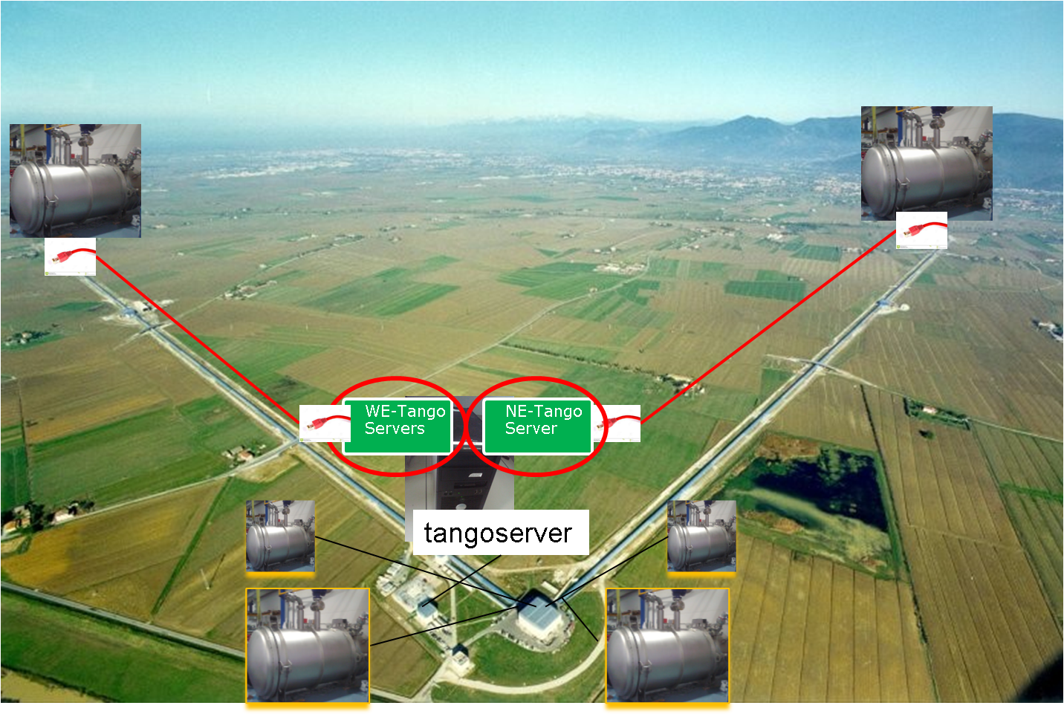
Figure 1 Large cryotraps controlled by tango servers

Cryotrap hardware controllers and modbus
The large cryotraps (Figure 2) are controlled by two Tango servers. The small cryotrap will be controlled by one Tango server. These devices are…
- CompactRIO Controllers from National Instruments (cRIO) control nitrogen levels in the large cryotrap. The controller was developed by Fred Schimmel (Nikhef).
- A beckhoff PLC is used to control valves, pumps and sensors on the large cryotrap. The controller was developed by Eric Jules (LAL).
- A Seneca PLC is used to control valves and sensors on the small cryotrap. The controller was developed by Giulio Ballardin (EGO).

Although the three hardware controllers are all different the three engineers involved agreed early to provide a modbus/tcp interface to allow communication with a Tango server. Modbus/tcp is a widely used communication protocol which has been successfully used previously to control devices at EGO. All Tango Servers run on a Debian linux platform and use the open source library libmodus for modbus/tcp communication.

Cryotrap setup at west-end and Tango
The first cryotrap installed at EGO was at the west end. Two Tango servers running on the machine tangoserver are used to control this cryotrap.
- Server crio/we-l1-01 is used to control the cRIO which controls the flow of liquid nitrogen.
- VacCryotrap/VacCryotrapWE is used to control a plc which controls pump’s diodes and sensors on the cryotrap.

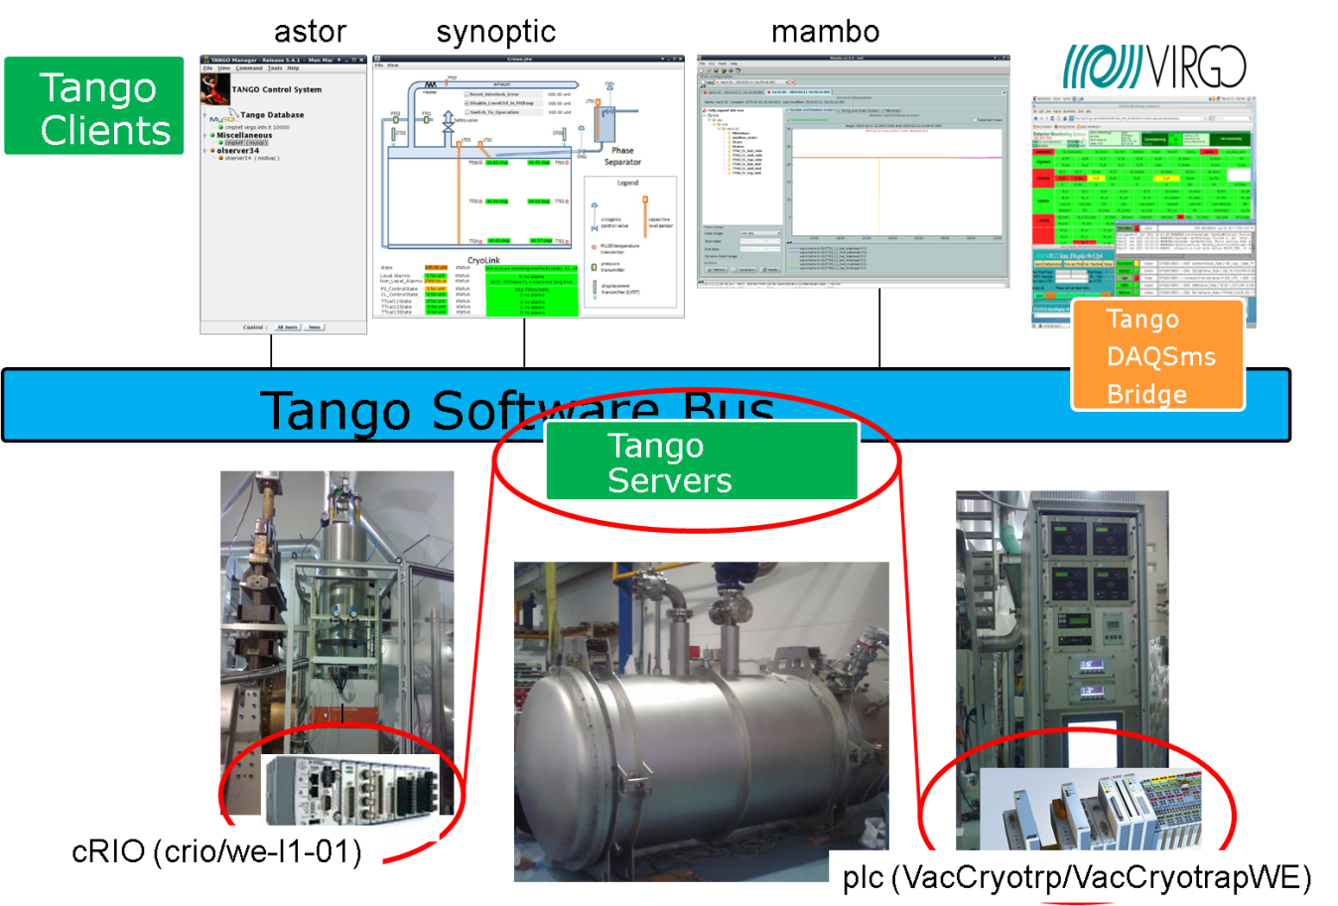
Figure 2 Tango Clients and Servers for the cryotrap control at west-end

Astor client
Tango clients are programs used to control or visualize tango servers. The Tango client Astor (Figure 3) can be used to control all the Tango servers.
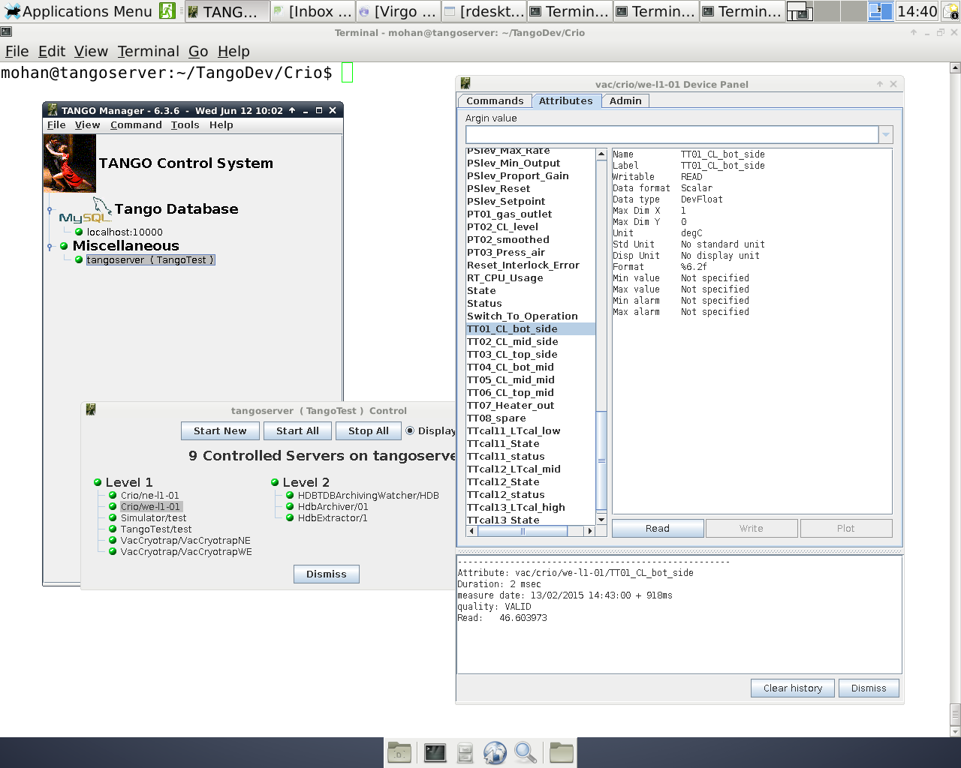
Figure 3 List of tango servers - vac/crio/we-l1-01

Currently 9 servers are being controlled by Astor (Figure 3).
- Three Level 2 servers are used by the Archiving system mambo.
- Two test servers Simulator/test and TangoTest/test.
- Two servers are used to control the cRIOs from Nikhef. One at the west end (Crio/we-l1-01) and one at the north end (Crio/ne-l1-01).
- Two servers are used to control the racks from LAL One at the west end (VacCryotrap/VacCrotrapWE) and one at the north end. (VacCryotrap/VacCrotrapNE).

A tango server can be used to control several devices but in our case one server controls one device. (E.g. The tangoserver Crio/we-l1-01controls the device vac/crio/we-l1-01)
A list of attributes and their values can be obtained in Astor by right clicking on the device.
E.g. Right click on Crio/we-l1-01 to get a list of attributes for device vac/crio/we-l1-01. TT01_CL_Bot_side represents an attribute associated with a temperature sensor. The temperature of TT01_CL_Bot_side on 13/02/2015 at 14:43 was 46.6 degC (Figure 3).

Astor is and one of many Tango clients. Several other Tango clients are being used to develop guis and interfaces. Agreement on which clients to use is needed to avoid duplication of effort.
Tango cryotrap servers for cRIO
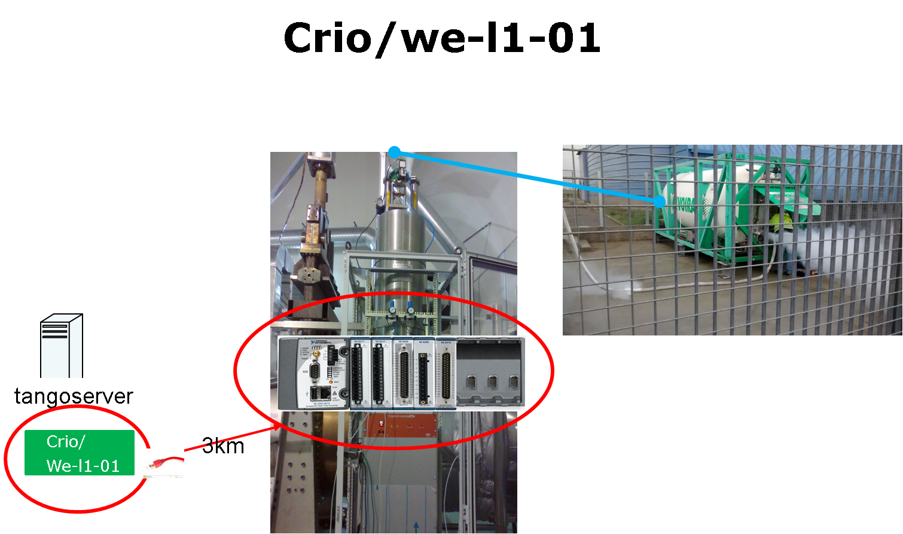
Figure 4 Controlling cRIO from tangoserver

The cRIO server is used to control liquid nitrogen intake. A table describing the ip address of the controller and the definition of each modbus address was created by Nikhef (Figure 5).

Entry | Variable | Dimension | DataType | Description
0 | TT01-CL-bot-side | degC | Rd_SGL | Temp CL middle @ arm-side
2 | TT02-CL-mid-side | degC | Rd_SGL | Temp CL bottom @ arm-side
4 | TT03-CL-top-side | degC | Rd_SGL | Temp CL top @ arm-side
6 | TT04-CL-bot-mid | degC | Rd_SGL | Temp CL middle @ middle
Figure 5 Extract of table describing some modbus addresses for the Crio.

The Tango server was developed using information in Figure 5. The value of modbus address TT01-CL-bot-side (Figure 5) is read from the cRIO by the Tango server.
Crio/we-l1-01 and put on the Tango bus as a Tango attribute TT01_CL_bot_side (see Figure 3).
cRIO performance
Monitoring the devices require that modbus data is polled regularly. The cRIO controller is 3km from the tangoserver computer and the modbus data competes with other network data for bandwidth. To avoid conflicts from other network traffic the modbus/tcp interface should ideally be plugged directly into the cRIO and not connected to the internet (ref [2]) but if this is not practical competing network traffic should at least be kept to a minimum.
The Tango tool mambo was used to monitor performance of cRIO on the west end and the north end for several days. The cRIO’s were polled every second and the data stored in an sql database every 10 seconds.

Archiving Data at west end (we-l1-01)
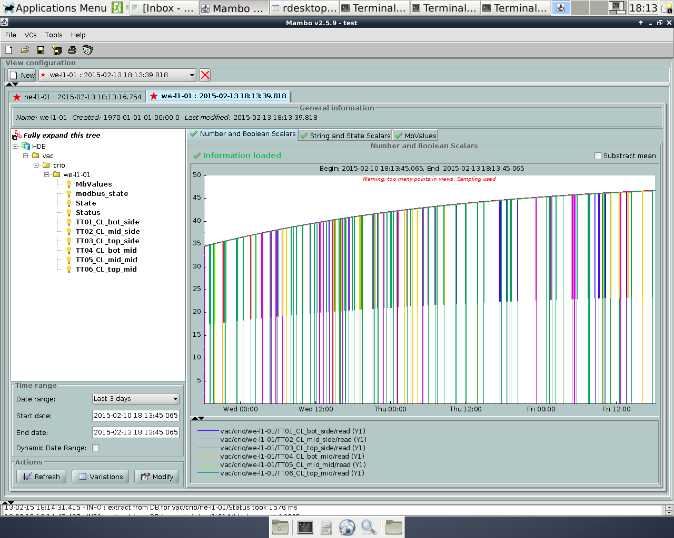
Figure 6 Data acquisition at the west end

Archiving Data at north end (ne-l1-01)
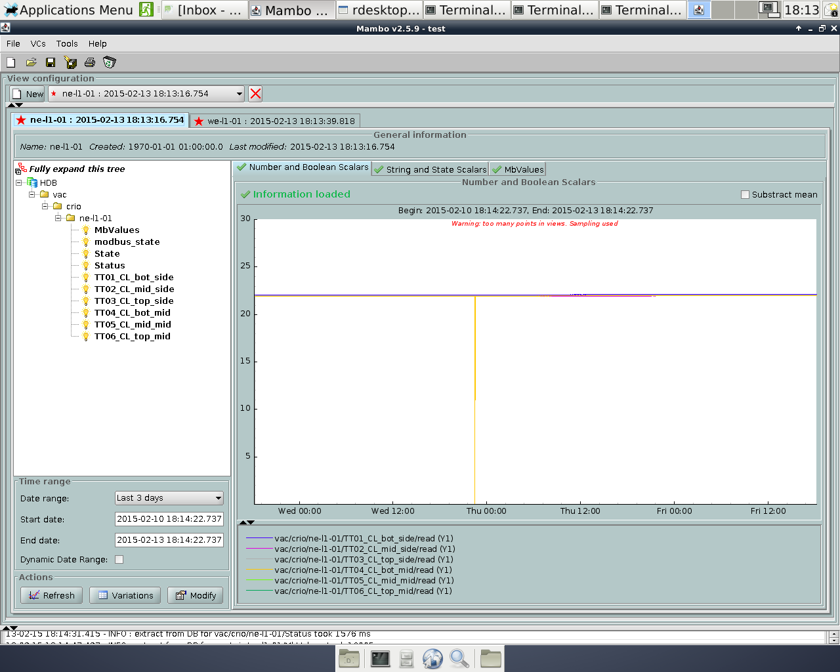
Figure 7 Data acquisition at the north end

Although both the hardware and software at the west end and the north end are identical the readout at the west end experienced periodic errors reading modbus values (Figure 8 and Figure 9).

During cool down testing phase the vacuum group wrote a program to poll the cRIO at the west end directly using modbus (ref [3]) .This server was still running and may have caused the conflicts?
To avoid conflict two controllers should not access the same device. Clients can poll data from the Tango software bus without polling the hardware directly.

Tango Integration at EGO
Current Situation
Early definition of Tango as the control system and modbus/tcp as the communication protocol for the control devices allowed testing and development to be carried out independently by engineers at Ego, Lal and Nikhef but now integration is required.
The electronics have been installed and tested at EGO. Tango servers are available for the large cryotraps and a Tango server is being developed for the small cryotraps. All servers may be controlled by Tango’s Astor tool.

Tango Integration requirements
Work on the vacuum control system required input from several different departments at EGO and co-ordination with Lal and Nikhef.
Previously the software group in the ITF department succeeded in collaborating between different EGO departments, Lal and Nikhef but this group ceased to exist in December 2013.
There is no software group at EGO to co-ordinate development which leads to miscommunication and unnecessary duplication of effort. Software has been developed which may cause conflicts and engineers are using different Tango clients.

Some tasks which require discussion and clarification by software developers are…
- Assign a Tango naming convention?
- Which Tango Clients should be adopted?
- Obtain and configure production computers for Tango?
- Who has access to Tango servers?
- Who will support and maintain software?
- Who is responsible for system administration?
- Training of operators on Tango?
Etc….
Conclusion
Some cryotrap Tango servers have been installed and tested at EGO but more work is needed for planning and integration.
Several engineers in different departments are developing software at EGO. It is difficult to avoid conflicts and duplication of effort without a software group co-ordinating efforts.

A commonly agreed naming convention still needs to be defined for all Tango systems...

