Images accompanying EGO-Virgo press release for the start of O3

The Virgo test-mass mirror inside its actuation-cage. The mirror and actuation-cage are both suspended from a Virgo Superattenuator. A layer of protective polymer (visible in pink) still covers the mirror, preventing dust contamination during installation. On the left, two mirrors can be seen. These are part of the sensor that monitors the tiny thermal deformations of the test-mass mirror occurring during operation. Black-coated panels surround the optical elements to absorb residual stray light.

Image credit: EGO/Virgo Collaboration/Perciballi
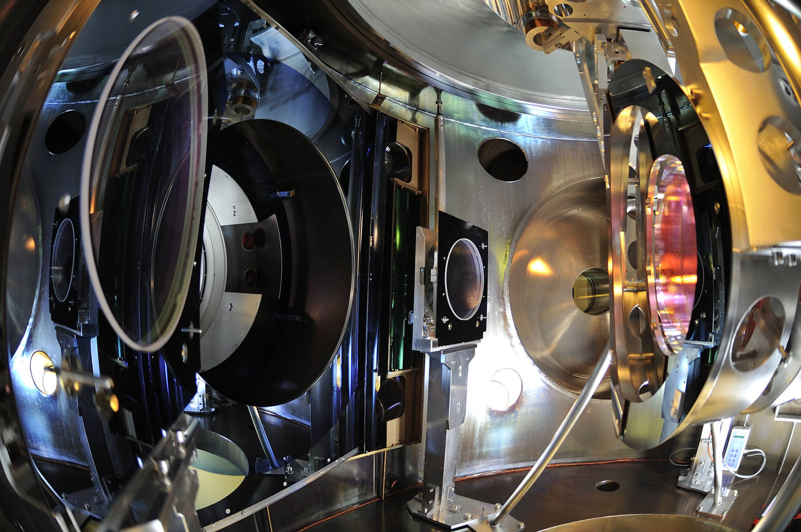
High resolution version at: https://owncloud.ego-gw.it/index.php/s/1i6xTL6HoxHu77k

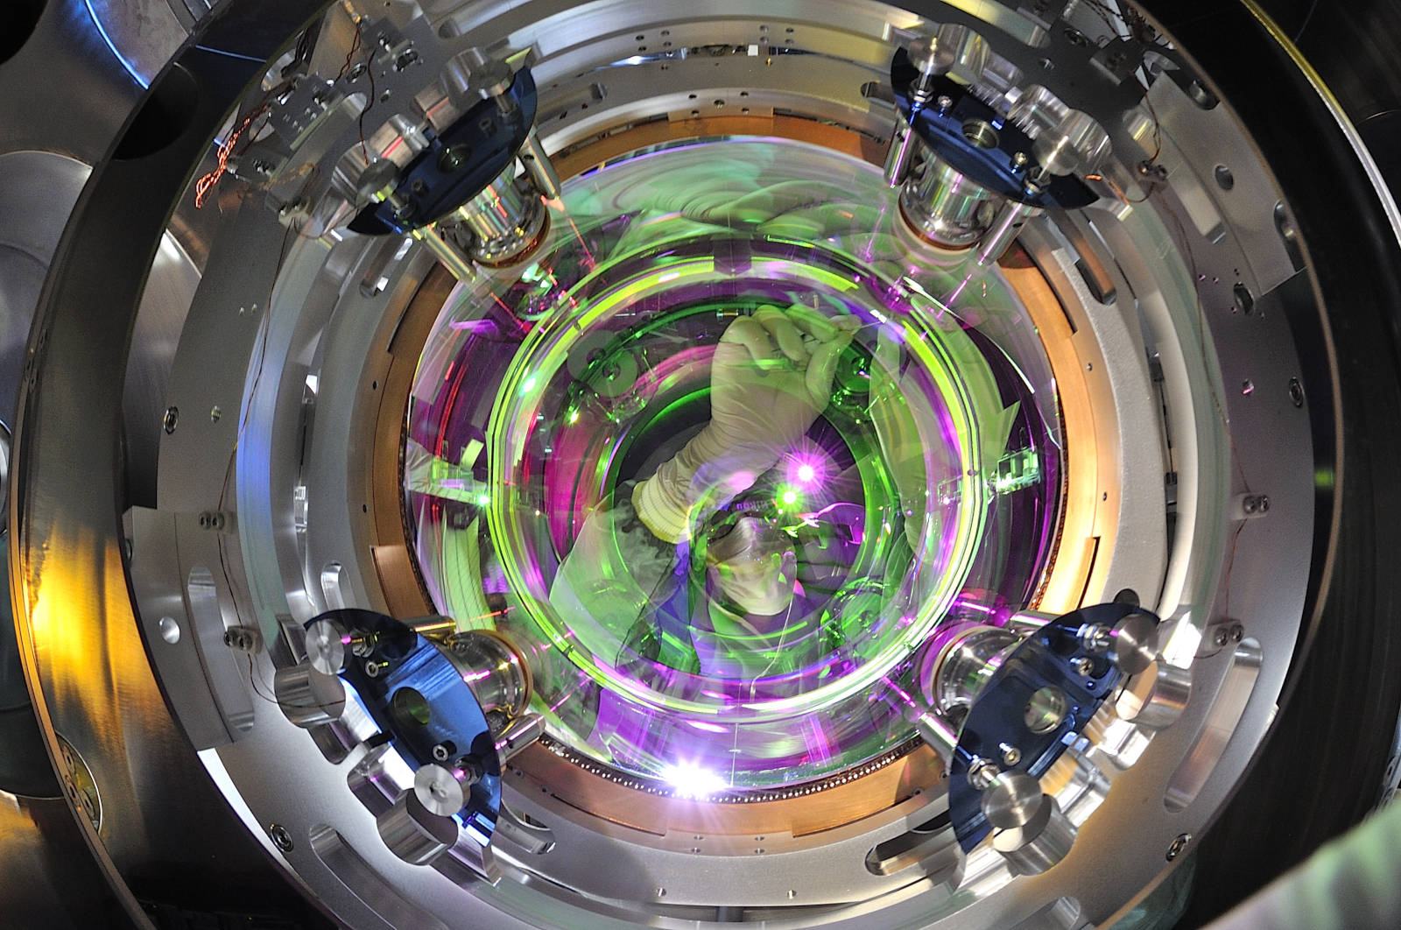

Rear-side view of a suspended mirror. The coating reflects the Virgo near-infrared laser beam, but is transparent in the visible range. A scientist is finally releasing the safety stops used during installation. The 42kg-mass mirror is suspended from four thin fused-silica fibres, which are bonded to the sides of the mirror.

Image credit: EGO/Virgo Collaboration/Perciballi
High resolution version at: https://owncloud.ego-gw.it/index.php/s/MntOk1ITEKSLka2

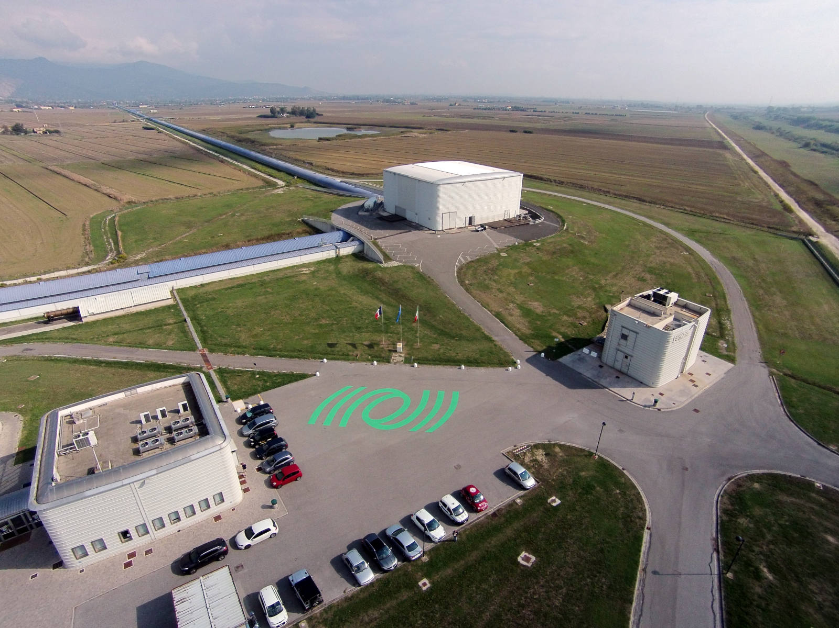

Aerial view of the Virgo interferometer at EGO, in Cascina (Pisa, Italy). The picture shows the Virgo Central Building, which hosts the laser source and most of the optics, along with their suspensions. The 3km-long blue North Arm (top) and West Arm (left) tubes, within which the Virgo laser beam propagates under vacuum, are clearly visible.

Image credit: EGO/Virgo Collaboration
High resolution version at: https://owncloud.ego-gw.it/index.php/s/GnHqYiOhQdqNdtN

